VNI West Environment Effects Statement (EES)

Scoping Requirements FAQs February 2025

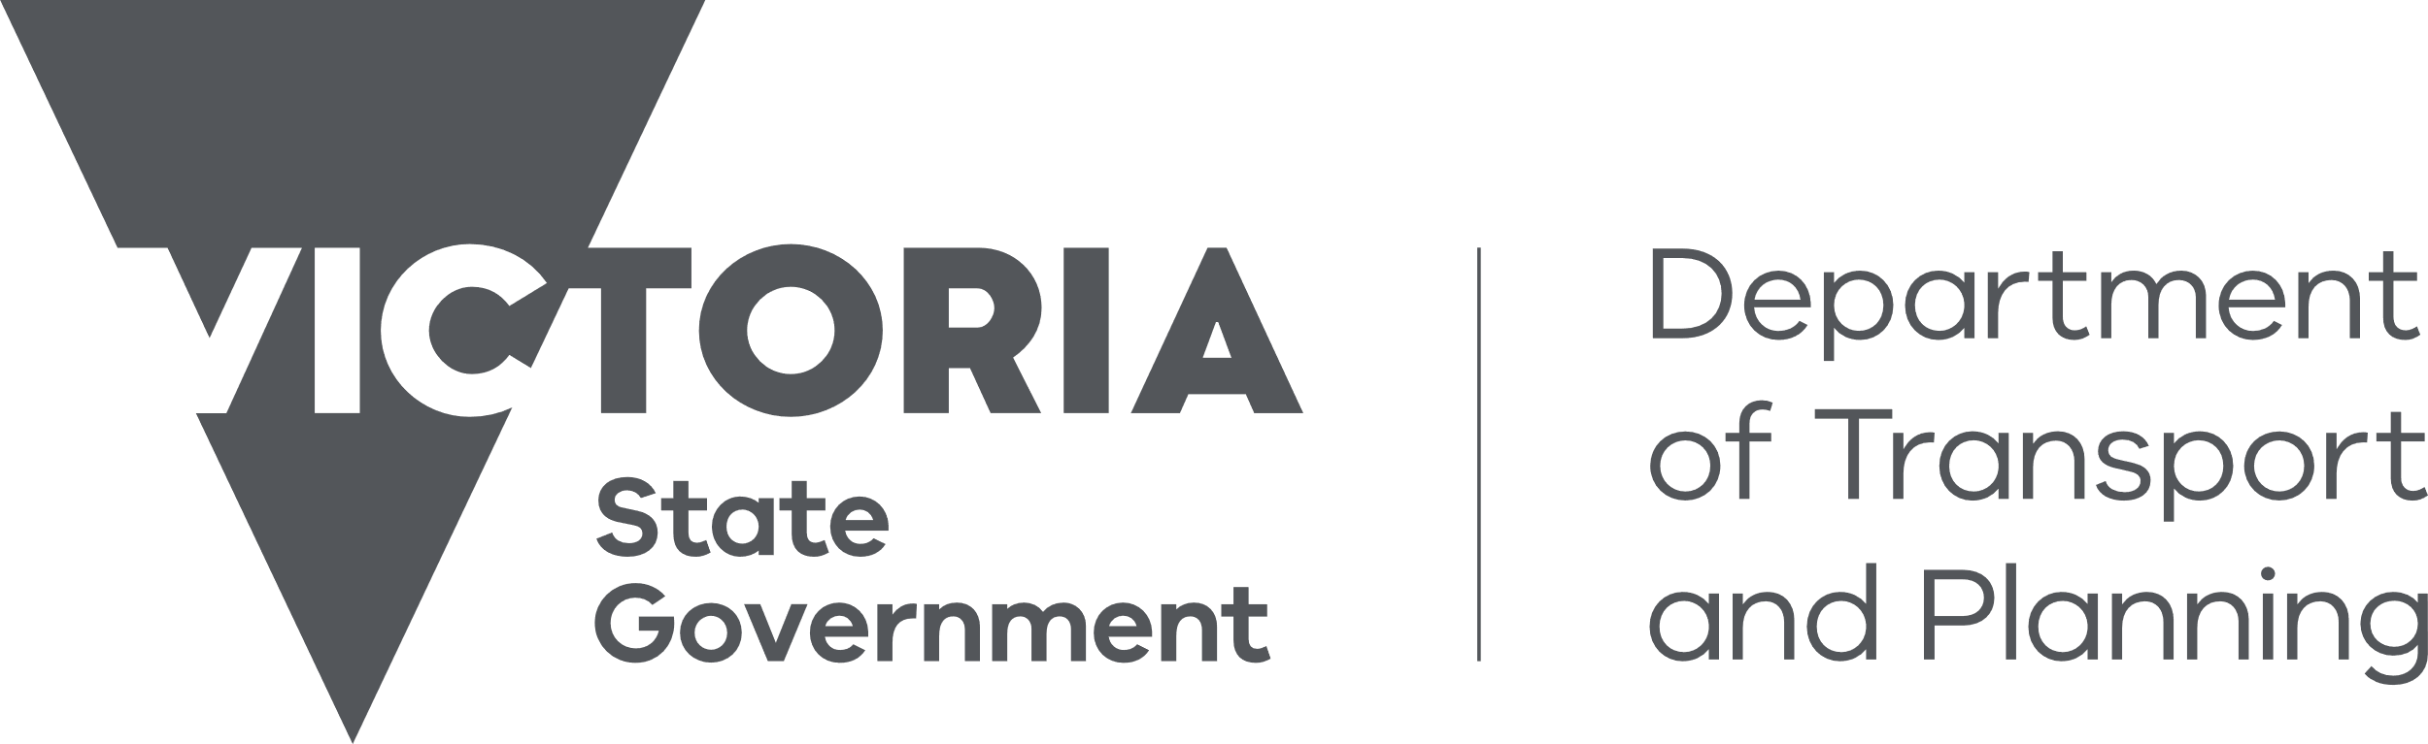

1. What is the VNI West project?

The VNI West project, is proposed to provide a link in the electricity transmission system between the Murray River and Western Victoria Renewable Energy Zones (REZs) in both Victoria and New South Wales (NSW) and load centres in those jurisdictions to strengthen the connection between power grids in NSW and Victoria.

The proposed project for assessment in the EES comprises the Victorian component of VNI West. This includes the construction of a new 500 kV double-circuit electricity transmission line with associated infrastructure situated within Victoria. The project consists of the following proposed components and activities:

* Development, construction and operation of approximately 240 km of new 500 kV overhead double circuit transmission line with steel lattice towers of between 60 m to 80 m in height.
* Construction of a terminal station at Tragowel (Tragowel Terminal Station), including both 500 kV and 220 kV equipment.
* Modifications to the existing 220 kV transmission line that runs between Kerang and Bendigo at the proposed Tragowel Terminal Station.
* A number of temporary construction laydown areas along the route.
* A draft transmission corridor within the Option 5A area of interest which has been identified as having the potential to accommodate the project infrastructure.

1. What is the purpose of the EES scoping requirements?

Transmission Company Victoria (TCV, the proponent) is preparing an environment effects statement (EES) for the VNI West project.

The scoping requirements set out the matters to be investigated and documented within the EES. The EES will include a description of the proposed project, rigorous assessment of its potential effects on the environment and approaches to manage those effects.

The EES scoping requirements have been issued by the Minister for Planning and are available on the Planning website:

<https://www.planning.vic.gov.au/environmental-assessments/browse-projects/referrals/victoria-to-new-south-wales-interconnector-west-victorian-component>

1. Did the public have an opportunity to comment on the scoping requirements?

Yes. Draft scoping requirements for the EES were exhibited on the Engage Victoria website from 28 November to 18 December 2024. Notice of the draft scoping requirements’ exhibition was advertised in metropolitan and local newspapers.

A total of 67 submissions were received during the public exhibition period, including from individuals and other stakeholders.

Submissions received have been provided to TCV, where permission was given, to inform the ongoing development of the EES.

1. What issues were raised in public submissions on the draft scoping requirements?

Issues raised by submitters included concerns about:

* general impact assessment methods and concern around reduction and mitigation of impacts across all aspects covered by the scoping requirements;
* economic impacts as a result of restrictions on land use and agricultural practices, reduction in property values, availability of housing and increased costs to homeowners
* ongoing mental health, stress and anxiety of those living in the area of interest;
* project viability and cost;
* ongoing consultation practices of the proponent and the timing of the exhibition of scoping requirements;
* ability to fight fires in and around transmission lines;
* cumulative impacts of renewable energy and transmission line projects and general energy distribution.

1. What revisions have been made to the draft scoping requirements in response to public submissions?

The changes made to finalise the scoping requirements were minor and largely involved the inclusion of specific aspects such as housing, wellbeing, agriculture and housing to clarify what should be considered when assessing the economic effects of the project and community and social setting.

Other changes included:

* Consideration of biosecurity risks and accessibility of land with farming equipment around transmission lines as an issue for Agriculture in Section 4.4.
* Consideration of the potential interaction of project infrastructure with floodwaters and potential changes to floodwater flows in Section 4.8.

Most of the other relevant concerns raised in the submissions were considered to be adequately covered by existing requirements. For example, concerns regarding impacts to agriculture, bushfire suppression are covered by the requirements of section 4.4, which requires the proponent to consider potential adverse impacts on agriculture or other forms of farming, and the implications of the project for fire risk management or bushfire suppression.

Further, concerns regarding impacts to biodiversity values, including threatened species, are covered by the requirements in section 4.2, which require the proponent to assess the direct and indirect effects of the project on native vegetation, listed ecological communities, and listed threatened, migratory and other protected flora and fauna species.

1. What happens now the Minister has issued the final scoping requirements?

TCV will address the matters set out in the scoping requirements through investigating environmental impacts, gathering information and preparing EES documents, in consultation with the Department of Transport and Planning and a technical reference group. The technical reference group is comprised of representatives from government agencies, regional authorities, municipal councils and registered Aboriginal parties (RAPs) with a statutory or policy interest in the project and its effects.

TCV will also engage the public and stakeholders about the environmental effects of the project and its investigations and provide opportunities for input and feedback to inform the EES. TCV’s EES consultation plan can be viewed at: <https://www.planning.vic.gov.au/environmental-assessments/browse-projects/referrals/victoria-to-new-south-wales-interconnector-west-victorian-component>.

When the EES has been completed in accordance with the scoping requirements, the Minister for Planning will authorise the EES for exhibition and public comment, typically for a period of 30 business days.

The Minister will appoint an inquiry under the *Environment Effects Act 1978* to consider the EES and submissions received. The inquiry may hold a formal hearing where the proponent and submitters can speak and present expert witnesses to inform a report to the Minister. The Minister will then make an assessment of the project’s environmental effects.

After the Minister has made an assessment, the inquiry report and the Minister’s assessment will be published on the Planning website.

The Minister’s assessment will be considered by statutory decision-makers responsible for the project’s approvals.

1. What about the Commonwealth Environment Protection and Biodiversity Conservation Act?

The project was also referred to the Australian Government under the Commonwealth’s *Environment Protection and Biodiversity Conservation Act 1999* (EPBC Act). The delegate for the former Minister for the Environment determined in June 2024 that the project is a ‘controlled action’ requiring assessment and approval under the EPBC Act. The provisions for the Australian Government’s controlled action decision under the EPBC Act are:

* Ramsar wetlands (sections 16 and 17B);
* listed threatened species and communities (sections 18 & 18A); and
* listed migratory species (sections 20 & 20A).

The EES process is accredited to assess impacts on matters of national environmental significance under the EPBC Act through the Bilateral (Assessment) Agreement between the Commonwealth and the State of Victoria. The EES for the project will be undertaken in accordance with the bilateral agreement; there will be no separate assessment by the Commonwealth. The Victorian Minister’s assessment will be provided to the Commonwealth to inform their decision about the approval required for the project under the EPBC Act. The final EES scoping requirements identify matters relating to the EPBC controlled action decision, so that the EES can appropriately address these matters of national environmental significance that need to be assessed.

1. **When does TCV expect to publicly exhibit its EES?**

The EES is expected to be on public exhibition in 2026. During this period, the public can make submissions on the EES.

1. **Why is an EES required for the VNI West project?**

In April 2024, the Minister for Planning determined that an EES is required for the VNI West project. This was because the project has the potential for a range of significant effects relating to:

* biodiversity and ecological values, including loss, degradation or fragmentation of native vegetation and habitat;
* Aboriginal and historic cultural heritage values;
* visual and landscape values;
* water environments including waterways, wetlands and groundwater; and
* agriculture, other land uses and communities.

The project also has the potential for cumulative adverse effects on the above-mentioned values from the combination of proposed works, and other existing and publicly known proposed projects within the region.

An EES is the most comprehensive and robust assessment process available in Victoria. The EES will provide an integrated and transparent examination of the proposed project and its environmental effects.