Hexham Wind Farm project Environment Effects Statement (EES)

Scoping Requirements FAQs September 2024



1. What is the Hexham Wind Farm project?

The Hexham Wind Farm project is a proposed wind farm located between the townships of Hexham, Caramut and Ellerslie in the Moyne Shire local government area of south-west Victoria. The project area is approximately 15 kilometres (km) west of Mortlake and 15 km north-east of Woolsthorpe. Hexham is the nearest settlement, approximately 3 km north-east of the project area (Figure 1).

The project consists of the following proposed components and activities:

* Up to 109 wind turbines with a maximum blade tip height of up to 260 m
* An on-site terminal station
* Approximately 142 km of underground cabling and 40km of overhead powerlines
* A battery storage facility
* Approximately 128 km of new access tracks and upgrades to approximately 29 km of existing tracks

The project proposes a total capacity of approximately 741 MW and annual production of approximately 2,850 GWh of electricity. The operational life of the project is anticipated to be 25 years.

1. What is the purpose of the EES scoping requirements?

Hexham Wind Farm Pty Ltd (the proponent) is preparing an environment effects statement (EES) for the Hexham Wind Farm project.

The scoping requirements set out the matters to be investigated and documented within the EES. The EES will include a description of the proposed project, rigorous assessment of its potential effects on the environment and approaches to manage those effects.

The EES scoping requirements have been issued by the Minister for Planning and are available on the Planning website:

[https://www.planning.vic.gov.au/environment-assessment/browse-projects/projects/hexham-wind-farm](https://www.planning.vic.gov.au/environment-assessment/browse-projects/projects/hexham-wind-farmt)

1. Did the public have an opportunity to comment on the scoping requirements?

Yes. Draft scoping requirements for the EES were exhibited on the Engage Victoria website from 10 July to 28 July 2023. Notice of the draft scoping requirements’ exhibition was advertised in metropolitan and local newspapers.

50 submissions were received during the public exhibition period, including from individuals, community groups, Moyne Shire Council, the Victorian Farmers Federation and other stakeholders.

Submissions received have been provided to Hexham Wind Farm Pty Ltd to inform the ongoing development of the EES.

1. What issues were raised in public submissions on the draft scoping requirements?

Key issues raised by submitters included:

* Concerns about impacts on brolga and the Southern Bent-wing Bat;
* Concerns about impacts on agricultural land-uses;
* Concern about noise impacts;
* Need for greater consideration of cumulative impacts from the other operational wind farms in the Moyne Shire.

1. What revisions have been made to the draft scoping requirements in response to public submissions?

Amendments have been made to the scoping requirements to address issues raised by submitters that had not been well considered in the draft scoping requirements. These amendments clarify the matters that are to be addressed in the EES. These amendments included updates to:

* clarify the assessment of cumulative impacts with other existing and proposed developments in the region, including wind farms that are operational within Moyne Shire;
* include risks to agriculture in the region (e.g. biosecurity), including the potential impacts on or of loss of agricultural land as a result of the project ;
* clarify the assessment of impacts downstream of the project, such as construction of roads to service quarries and ports and transmission infrastructure;
* clarify the assessment of the potential socio-economic effects of the project including housing availability for workers within the area;
* outline the proposed approach for site reinstatement where relevant, including the approach to decommissioning wind turbines and associated infrastructure and the rehabilitation of the on-site quarry;
* clarify the approach to giving mitigation measures statutory weight, including proposed community benefits being adequately secured should the project be on-sold.

1. What happens now the Minister has issued the final scoping requirements?

Hexham Wind Farm Pty Ltd will address the matters set out in the scoping requirements through investigating environmental impacts, gathering information and preparing EES documents, in consultation with the Department of Transport and Planning (formerly the Department of Environment, Land, Water and Planning) and a technical reference group. The technical reference group is comprised of representatives from government agencies, regional authorities, municipal councils and registered Aboriginal parties (RAPs) with a statutory or policy interest in the project and its effects.

Hexham Wind Farm Pty Ltd will also engage the public and stakeholders about the environmental effects of the project and its investigations and provide opportunities for input and feedback to inform the EES. Hexham Wind Farm Pty Ltd’s EES consultation plan can be viewed at: <https://www.planning.vic.gov.au/environment-assessment/browse-projects/hexham-wind-farm.>

When the EES has been completed in accordance with the scoping requirements, the Minister for Planning will authorise the EES for exhibition and public comment, typically for a period of 30 business days.

The Minister will appoint an inquiry under the *Environment Effects Act 1978* to consider the EES and submissions received. The inquiry may hold a formal hearing where the proponent and submitters can speak and present expert witnesses to inform a report to the Minister. The Minister will then make an assessment of the project’s environmental effects.

After the Minister has made an assessment, the inquiry report and the Minister’s assessment will be published on the Planning website.

The Minister’s assessment will be considered by statutory decision-makers responsible for the project’s approvals.

1. What about the Commonwealth Environment Protection and Biodiversity Conservation Act?

The project was also referred to the Australian Government under the Commonwealth’s *Environment Protection and Biodiversity Conservation Act 1999* (EPBC Act). The delegate for the former Minister for the Environment determined in August 2022 that the project is a ‘controlled action’ requiring assessment and approval under the EPBC Act. The provisions for the Australian Government’s controlled action decision under the EPBC Act are:

* listed threatened species and communities (sections 18 & 18A); and
* listed migratory species (sections 20 & 20A).

The EES process is accredited to assess impacts on matters of national environmental significance under the EPBC Act through the Bilateral (Assessment) Agreement between the Commonwealth and the State of Victoria. The EES for the project will be undertaken in accordance with the bilateral agreement; there will be no separate assessment by the Commonwealth. The Victorian Minister’s assessment will be provided to the Commonwealth to inform their decision about the approval required for the project under the EPBC Act. The final EES scoping requirements identify matters relating to the EPBC controlled action decision, so that the EES can appropriately address these matters of national environmental significance that need to be assessed.

1. **When does Hexham Wind Farm Pty Ltd expect to publicly exhibit its EES?**

The EES is expected to be on public exhibition in early 2025. During this period, the public can make submissions on the EES.

1. **Why is an EES required for the Hexham Wind Farm project?**

In April 2022, the Minister for Planning determined that an EES is required for the Hexham Wind Farm project. This was because the project has the potential for a range of significant effects relating to:

* significant biodiversity values, including threatened species and communities listed under the *Flora and Fauna Guarantee Act 1988* and *Environment Protection and Biodiversity Conservation Act 1999*;
* native vegetation and ecology of the area’s terrestrial environments and freshwater environments, including wetlands and creeks;
* the Aboriginal cultural heritage; and
* landscape and visual amenity.

There is uncertainty about the extent and magnitude of potential effects related to historic heritage, traffic, shadow flicker, soils, groundwater, electromagnetic interference, aviation, amenity and socioeconomic values that also require further assessment.

The project also has the potential for cumulative adverse effects on the above-mentioned values from the combination of proposed works, and other existing and publicly known proposed projects within the region.

An EES is the most comprehensive and robust assessment process available in Victoria. The EES will provide an integrated and transparent examination of the proposed project and its environmental effects.

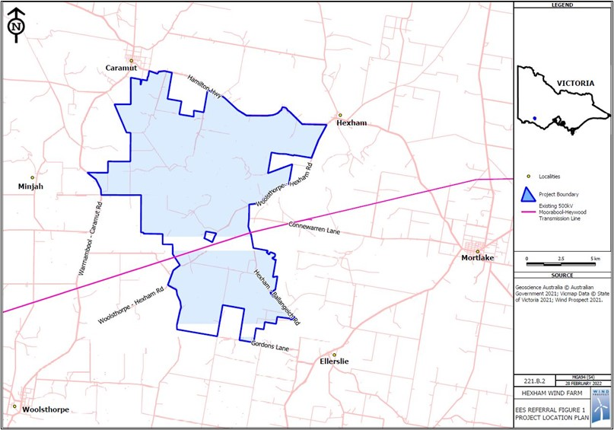

Figure 1: Project location (Hexham Wind Farm project)