State Project Facilitation (SPF) Portal
User Guide for Proponents and Alliances

The SPF portal is to be used to define state projects and lodge applications for various planning approvals against the relevant project. The portal provides a simple pathway for creating applications and gives proponents real time updates on the progress of applications.
Proponents can also request pre-application meetings with DELWP’s State Project Facilitation service via the portal, to seek guidance on progressing State Projects through the planning system and lodgement of applications.
Planning approval applications that can be lodged in the portal include:
- Project area designation declarations made under the Major Transport Project Facilitation Act 2009;
- State Project decisions and other relevant planning approvals for Civil and Infrastructure projects made under Clause 52.30 of the Planning & Environment Act (P&E Act) 1987; and
- Various planning approvals made under the P&E Act 1987
  - Clause 52.03 (Level Crossing Removal Projects)
  - Clause 52.35 (Major Road Projects)
  - Clause 52.36 (Rail Projects)
- Applications for consent under an incorporated document
The SPF portal does not support the lodgement of Planning Scheme Amendments. To request a planning scheme amendment please log in to the Amendment Tracking System.
Access to the portal is by invitation only. An email can be sent to state.projects@delwp.vic.gov.au to request access. Your access request will be reviewed and if granted, you will receive an email to complete setup.
We use Atlassian’s software to collect forms and manage the process for State Project Facilitation. When signing up, you agree to Atlassian’s Privacy Policy and Notice and Disclaimer.

The portal can be accessed from: https://stateprojectfacilitation.atlassian.net/servicedesk/customer/portals

Overview and Important things to note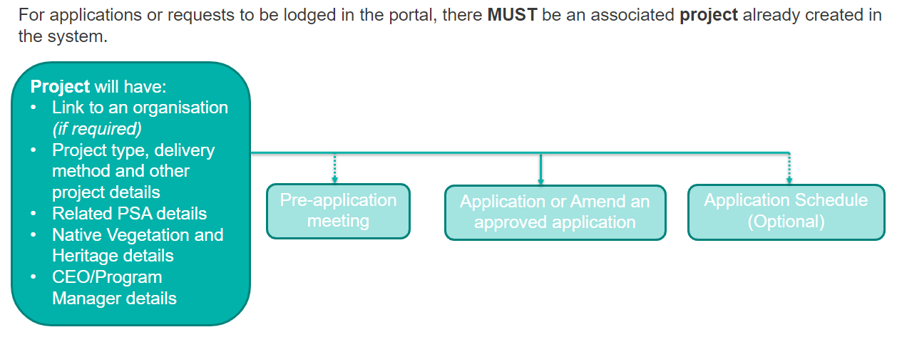

- A project must have at least one site defined, such as the land being affected by the project or can have multiple project sites.
- Each application will be linked to a project and applications can be created from the project screen
- Applications can be created and updated at any time up until they are submitted to the department for assessment, at which time they will be locked.
- The contact for the application, the RAG status and RAG comment can continue to be updated on an application

The following guide covers various tasks that can be managed using the SPF portal and includes;
Glossary of terms 3
Reset your password 4
Update profile settings 5
Navigating the system to access drafted requests and track the status of submitted requests 6
Create a project 7
Completing and submitting the Environmental impact details form on a Project 12
Create a request for a pre-application meeting 14
Creating a request for a pre-application meeting from a project 14
Create a request for a pre-application meeting from the home screen 15
Create and lodge an application 20
Create an application from a project 20
Create and lodge and application form from the home screen 21
Amend a previously approved application 28
Upload files after application has been saved 34
Share projects or applications with other registered users 35
Respond to a request for further information 36
Withdraw an application or pre-application request 39
Place application on hold / Request to take off hold 40
Notify the State Project Concierge team of change in application’s progress status (nominated projects only) 42
Update the reporter/contact on an application 44
Generate a report using Advance Requests report 46
Which Planner is assigned to my application? 47
Understanding the status of an application 48
Need further help or have feedback? 48

Glossary of terms
Closed requests | Includes any requests that have the status of complete.
DELWP | Department of Environment, Land, Water and Planning
Issue links | Refers to other requests that are linked to a specific request. For example, a project will have links to applications, pre-application meeting requests or an application schedule.
Open requests | All active requests raised in the portal that have not been submitted or that are actively being assessed by the department.
Participant | A user/managers group (managers of a proponent) of the system that has had a request (e.g. application/project) shared with them.
Portal | Refers to the system that is used to lodge applications to the State Project Facilitation team.
Project | The initiative driving the delivery of set outcomes and can cover one or more sites. Each project will include contact details, details of delivery method, construction dates, environment effects statement, details of vegetation removal, etc.
Project site | Also known as site, this is land that is affected by the project and can be represented as a site name suburb, or precinct relevant to the project.
Request | Can also be referred to as an issue and can be a project, application schedule, pre-application meeting request, application or amendment to a previously approved application. Each request type has a unique icon and will have separate associated form(s) with it.
RAG status/RAG Comment | There is functionality in the system where the State Project Concierge team can be notified of a change in an application’s progress status for a nominated project. See the section ‘Notify the State Project Concierge team of change in application’s progress status (nominated projects only)’ for further details.
Requestor/Reporter | Will be either the user of the portal who created the request or the main contact for an application.
SPF | State Project Facilitation

Reset your password
If you have been provided access to the portal but unable to recall the password you used, you can reset it.
- At the login screen, enter your email address and select Next. 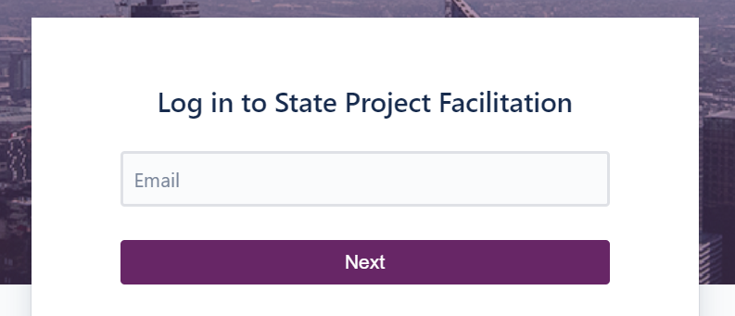
1
- Select ‘Forgot your password?’ 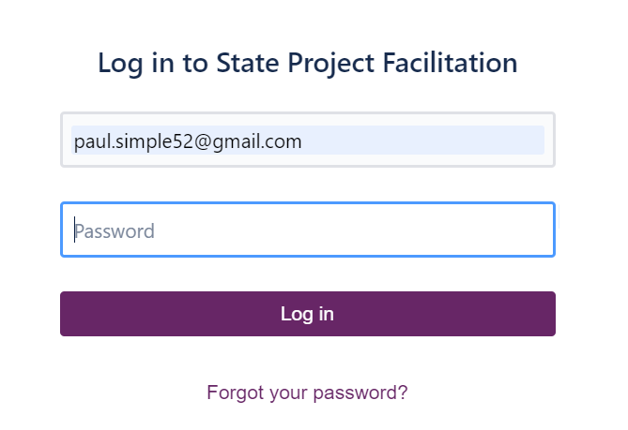
2
- An email to reset the password will be sent to the email address entered, if it is registered in the system. Follow the instructions of the email. If further assistance is required, email state.projects@delwp.vic.gov.au .

Update profile settings
When access has been granted to the system, it is important that you update your profile settings.
- From the home screen, select the profile icon and select Profile. 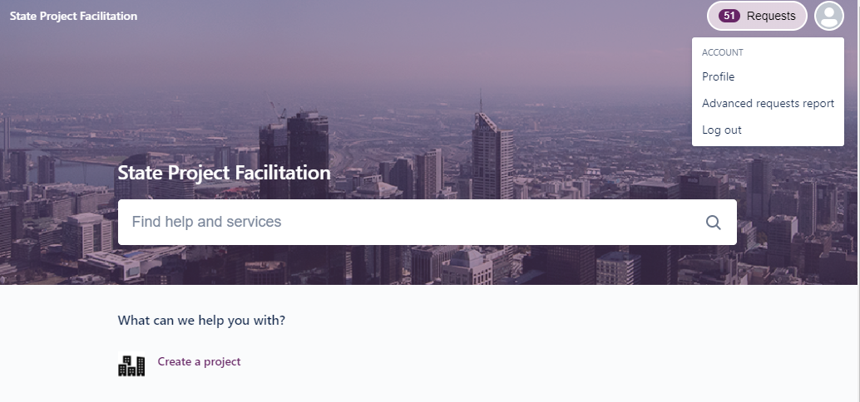
1
- Update the Name field with your first name and last name.
- Update the Language to be English (United Kingdom) and ensure that the time zone is Australia, (GMT+10:00) Melbourne.
- Select Save.
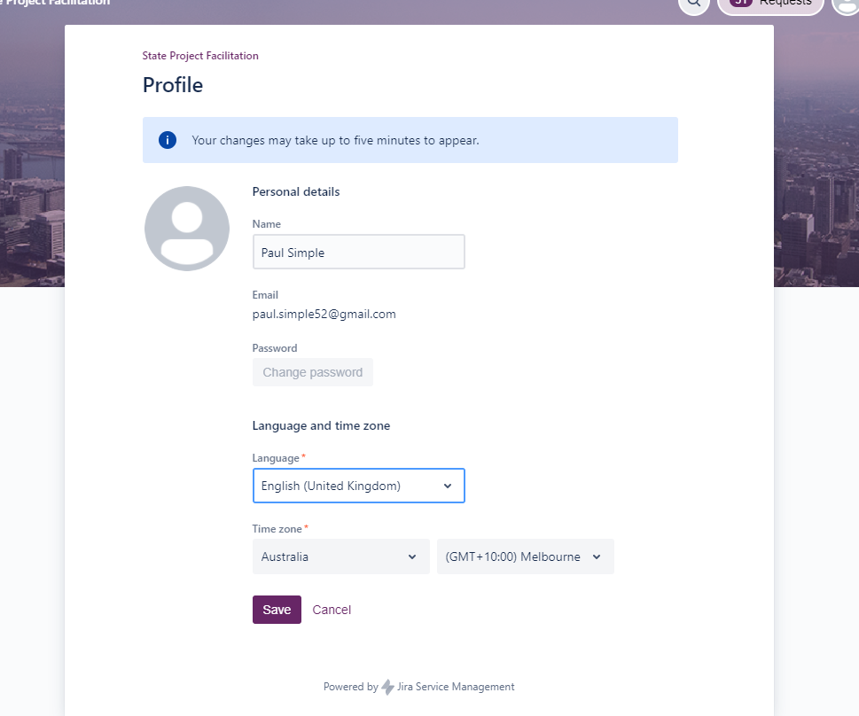
3
4
2

Navigating the system to access drafted requests and track the status of submitted requests
After a project has been created and any subsequent applications or pre-application requests are created and/or submitted, they will be made available via the ‘Requests’ area of the portal. The ‘Requests’ section will show the current status for applications or other request types.
- To access the requests that you have drafted, lodged or that have been shared with you, select the Requests button located at the top right of screen and choose either to see only those created by you, or ‘All’ to include requests that have been shared with you. TIP: If accessing the Request listing whilst completing an application form, select Requests and right-click ‘All’ to open link in new tab so that the application form remains open in the existing tab. 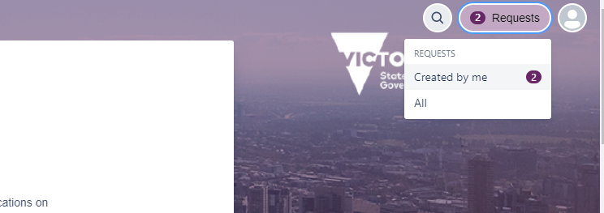
1
- At the Requests listing screen, select any of the reference numbers to navigate to the selected request.
- Filters located at the top of the listing can be used to enter a whole word which should search the key, summary and comments fields of requests in the listing.
- Hovering over the icons will advise the type of request.
- Selecting the elipses (…) will allow you to customise the listing.
- Select State project facilitation to return to the main page. 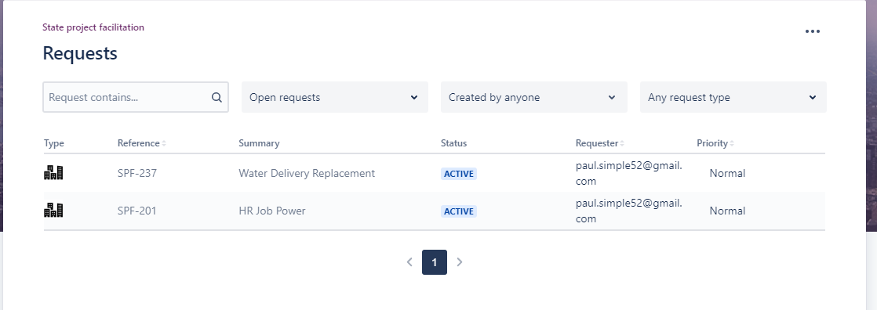
3
4
2
5
6

Create a project
In order to create and lodge an application or request for a pre-application meeting, there must first be a project created in the system. Project details such as site(s) and relevant planning scheme(s) will auto populate into applications raised from the project screen. These details can be edited as required during the application drafting process.
- From the home screen, select Create a project. 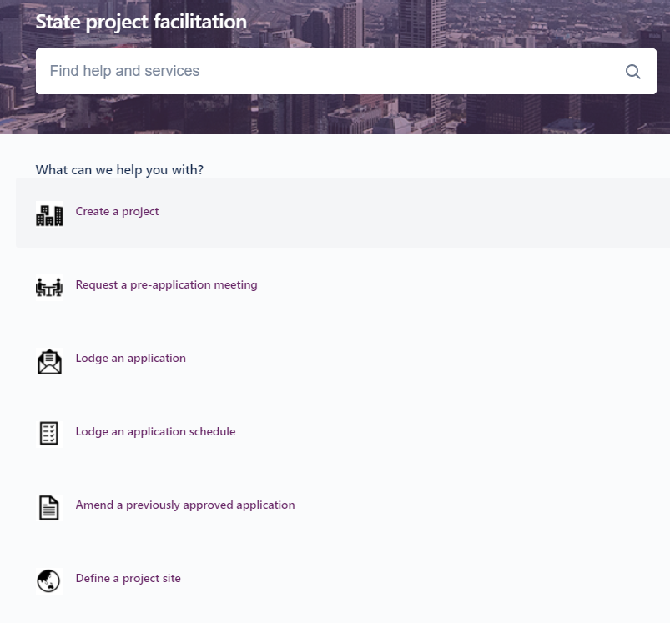
1
- If your user access is configured to view all requests under a managers group, you will see the ‘Share with field’. If you do not see this field, you will need to share the project with the managers group after it is created. (See step 8 of this section)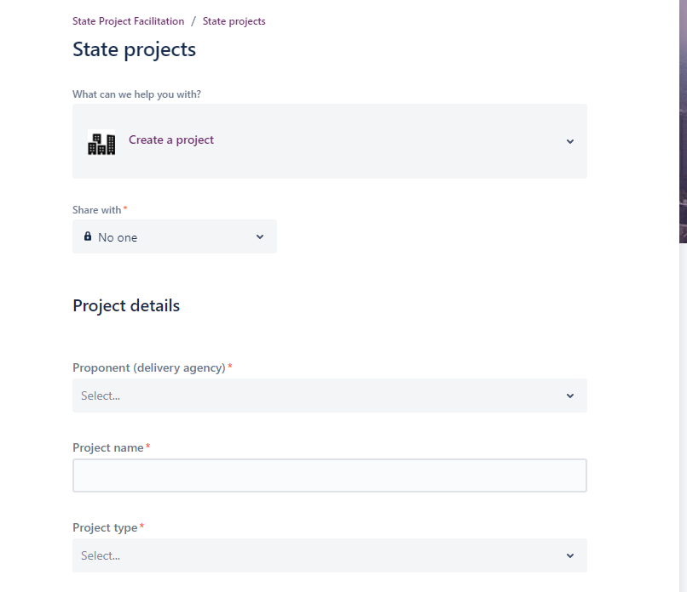
2
- Complete the form with the details of the project, ensuring all mandatory fields are completed. Additional details can be added to the project at a later stage or when more details become available.Some items to note:
  - Site names can be entered in the project form as well as any planning schemes covering the project land. These details will auto populate in any application that is generated from the project screen. For applications that are not created from the project, you will have an option to copy these details into the new application form.
  - The Applicant details should reference the individual that all formal communication such as approval letters will be addressed to e.g. CEO or Program Manager
- Review the privacy statement and when ready, select Send to save the form. 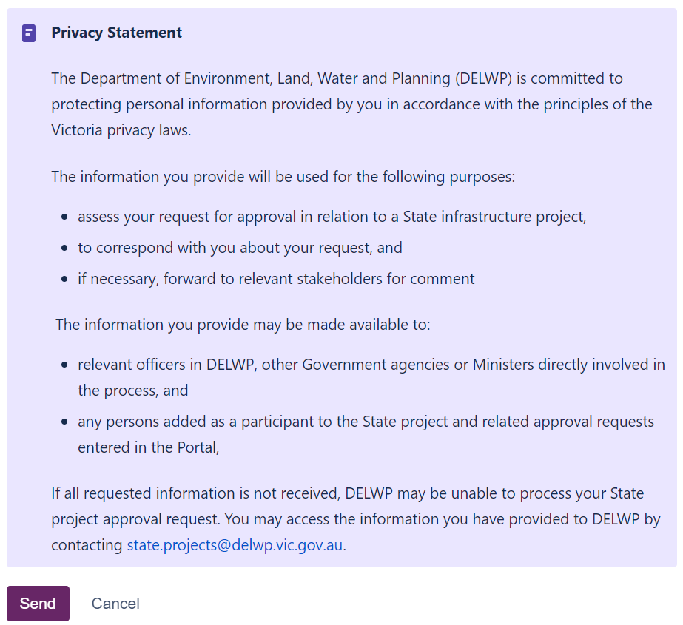
4
- After the form has been saved, refresh the web page (F5). The status should update to ACTIVE.
- Selecting Edit will open the form and allow you to make changes to any of the fields. Ensure that any changes are saved by selecting the Save button. Do not select Save and Submit.
- Select the elipses (…) to download a copy of the form if needed.
- If you would like to share the project with another registered user or to a mangers group, Select + Share. Any users that you add to the form will be listed under the ‘Shared with’ section. The project can also be shared at a later time if needed. 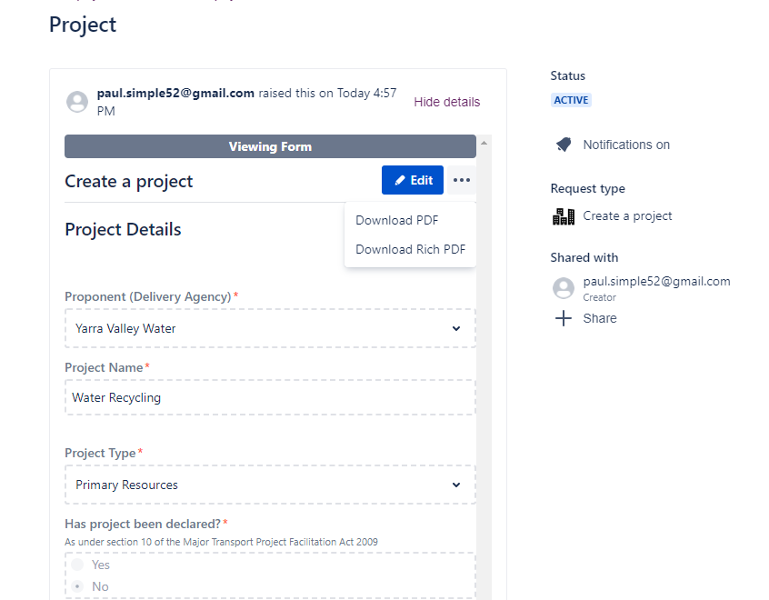
6
7
8
5
- When sharing the project, the staff member who you are sharing it with will receive an email to let them know that the project is shared with them.
Example of email with link to form: 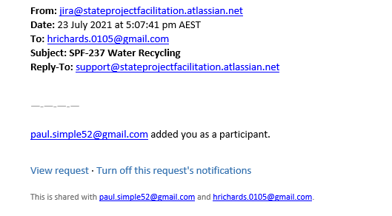

- You should note down the unique identifier which starts with SPF-XXX. This number will be required if creating an application, requesting a pre-application meeting or application schedule from the home screen. 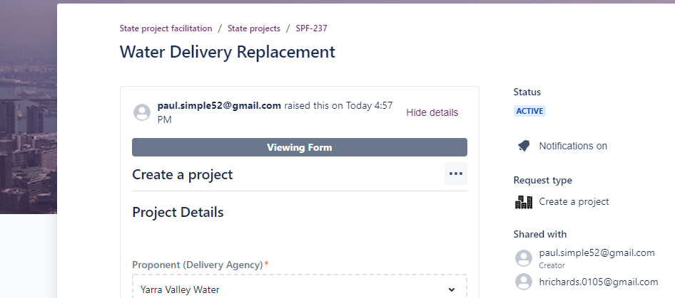
10

Completing and submitting the Environmental impact details form on a Project
After creating a project in the system, the reporter may be requested by the department (DELWP) to provide additional information regarding environmental impact details. The reporter will receive an email detailing the additional details needed and the email will include a link to the project record.

- Open project record via the link from the email or via the requests section of SPF Portal. 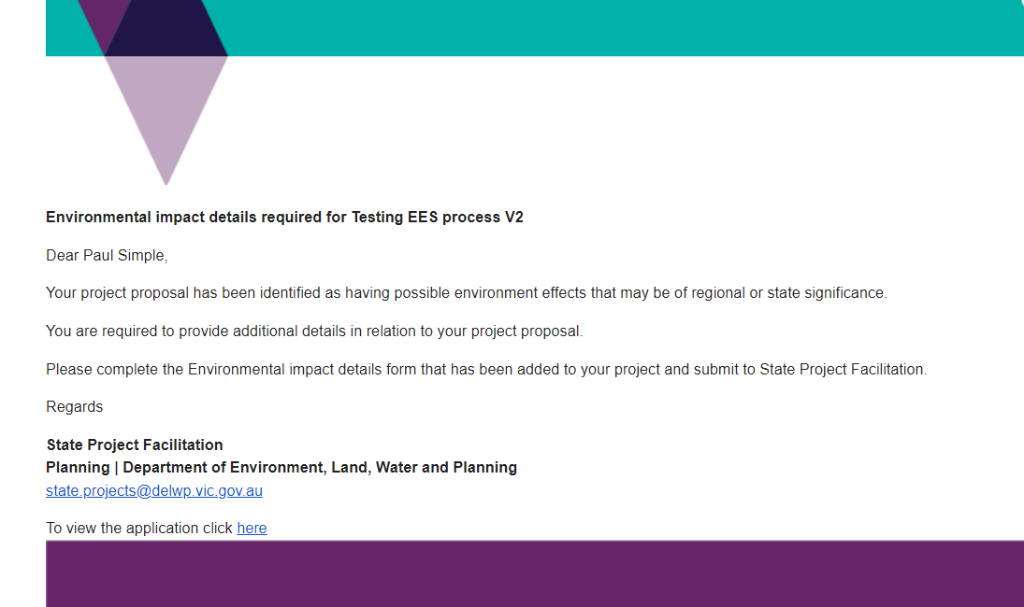
1

- Navigate to the Form Name section located at the top of the project record and select the Environmental impact details form to view. Select Edit to unlock the form and to enter data. 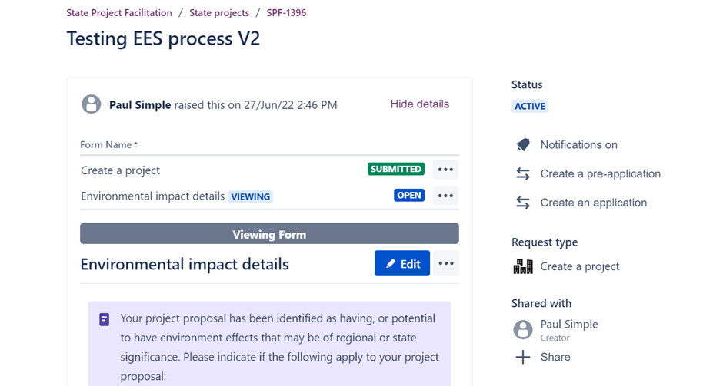
2
- Complete relevant details on the form. Select Save to keep changes or Save and submit to return the completed form. The form will be locked and no further changes can be made unless unlocked by the department. 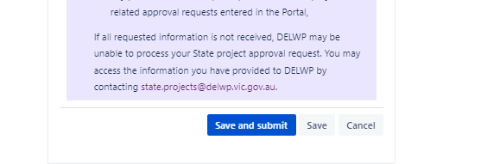
3
- Upon submission of the form, the assigned officer (Planner from DELWP) will receive a notification of the returned form.
- Additional documents may be attached to the project if needed via the Activity section located at the end of the project form page. See the section of this guide on how to upload documents in the Activity section of the project record. 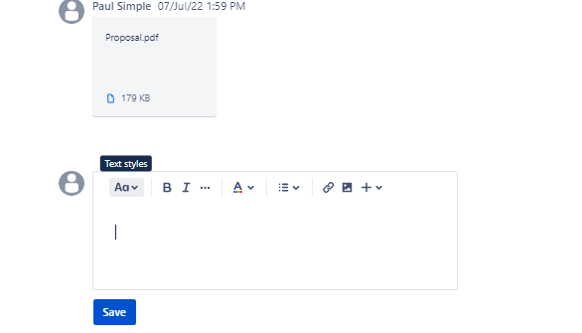
5

Create a request for a pre-application meeting
Requesting a pre-application meeting is optional. This is only required if you would require guidance or advice from the department on planning requirements for state planning projects and the approval process. As with any request, it is important that as much information is included and supporting documents attached to the request.
The first stage of this process is to create the pre-application meeting request which will be saved so that it can be reviewed prior to submission to the SPF team. Documents supporting the request can be uploaded at the time the request is created or by using the comments section where files can be uploaded.
A reminder that a project must exist prior to creating a request for a pre-application meeting.

Creating a request for a pre-application meeting from a project
If a project has been shared with a user, they will be able to access the project form where they can then choose to create a request for a pre-application meeting which will pre-populate the request form with details from the project.
- With the project open, select ‘Create a pre-application’. 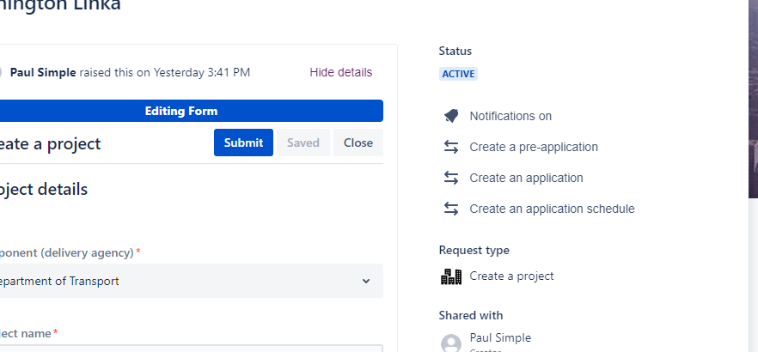
1
- You can enter an optional comment or select Create a pre-application. 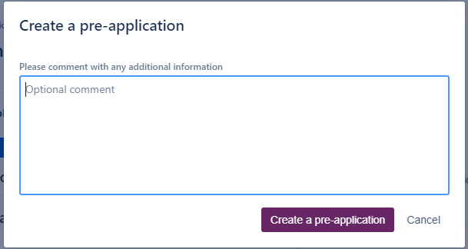
2
- The system will take approximately 10 seconds to create the pre-application form where during this stage, the status will appear as CREATING A PRE-APPLICATION REQUEST.
- Once the status returns to ACTIVE, refresh the web page (F5) to see the new form in the listing of Issue links. Select the pre-application form to open in a new browser tab. 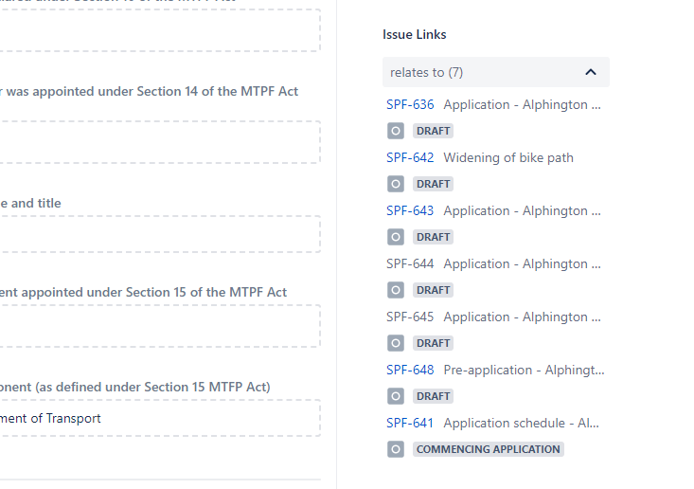
4
- Follow steps 14 to 22 to edit the details of the request and to submit to the department. Noting that as the pre-application was created from the project screen, details such as site names and planning scheme information will automatically be populated from the project into the pre-application but these details may need to be subsequentially updated.

Create a request for a pre-application meeting from the home screen
Users can also create a request for a pre-application meeting from the SPF portal’s home screen but they will need to have the project number ready to enter into the form (e.g. SPF-XXX). See the section for navigating the system if you need to find the project number.
- Whilst logged into the portal, from the home screen, select ‘Request a pre-application meeting’. 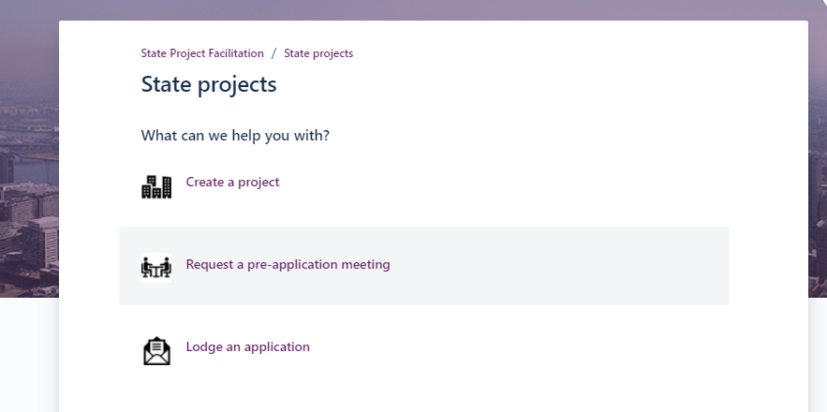
6
- After the form loads, if your access is linked to a managers group, you will see an option to share the request with your listing manager’s group. This field will not be visible if your access is not linked to a manager’s group. Also, the application can be shared at a later time to the manager’s group and/or registered user.
- Scroll to the Project details section and enter the relevant project number where this pre-application relates to. This will link the application to the project and automatically share the application with the same registered users that had the project shared with them previously.
- Update site details and planning scheme information as needed. You can choose to use the update site details and planning scheme information from the linked project by selecting ‘Yes’ then leave the fields empty, or if ‘No’, the site names and planning scheme information will need to be added. 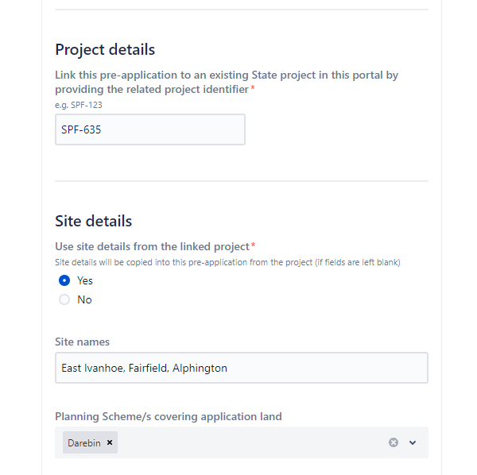
8
9
- Upload files such as indicative development plans, images, maps and consultation report by following the on-screen instructions to either drag and drop files or browse to upload (located top of form).
Alternatively, if the form is being edited after the initial save, attachments can be uploaded into the Activity/Comments section of the form.
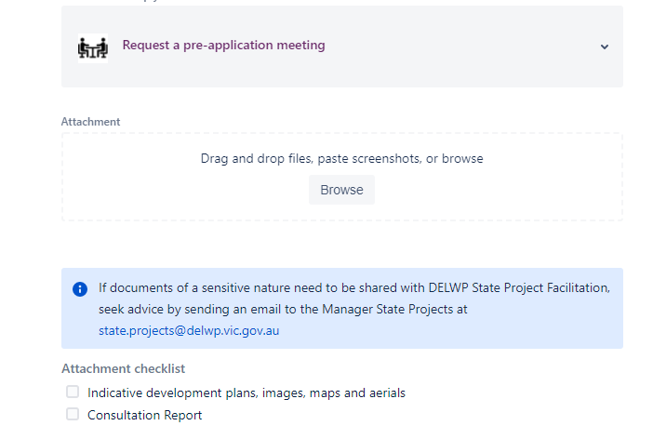
10
- Complete all fields of the form where possible, ensuring that all mandatory fields marked by a red asterix (*) are completed. Some fields may prompt you to complete further information also.
- Once all details of the form are complete and all necessary files uploaded, scroll to the end of the form. Select Send to save a draft of the form. Note that the request will not have yet been submitted to the department.
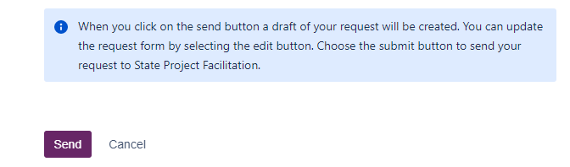
12
- Once saved, the pre-application meeting request will appear on screen with the status of DRAFT.
- Selecting the ellipses will show further functionality to download a PDF of the request.
- Selecting Edit will open the request form to enable update to fields and how the form can be submitted. 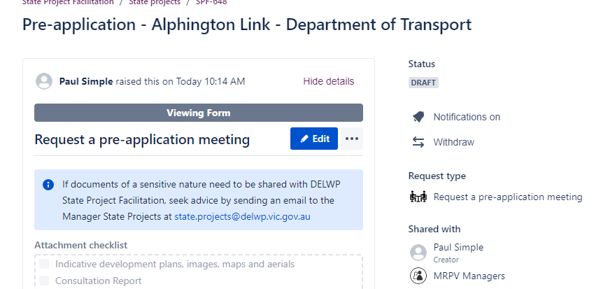
14
15
13
- Attachments that had been uploaded will appear to the right under ‘Attachments’. To upload additional supporting documents, scroll to the Activity section of the screen (end of screen) and select Add a comment.
16
- Select the Files & images icon to upload files from your device. You can add a comment if needed and select Save when ready. Multiple files can be uploaded. 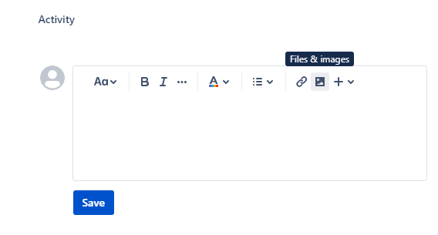
17
- Review all information and when ready for lodgement to the SPF team, select Save and submit (or Submit, if no changes made)
18
- At the next screen, select Submit to confirm the lodgement of the pre-application request with the department. 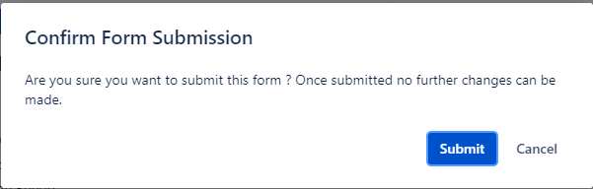
19
- Once lodged, refresh (F5) the screen to see the request status update to RECEIVED.
The form will be locked and no changes can be made.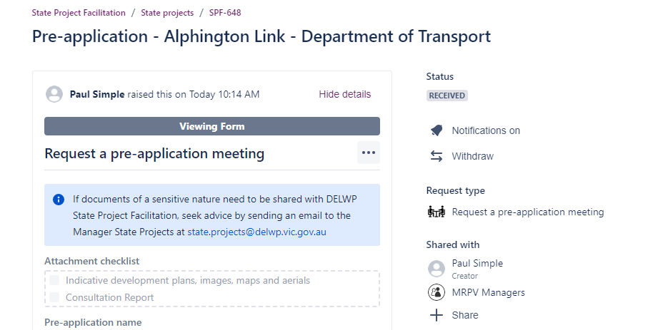
20
- If additional information needs to be submitted (including documents) they can be added by using the comments section located at the end of the form under ‘Activity’.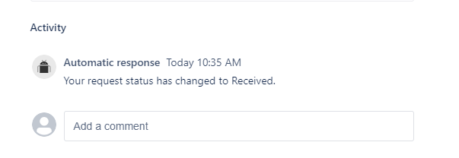
21
- The pre-application meeting request will be assigned to a planner who will contact the creator (contact) regarding the request.
- Any updates to the request, including confirmation of meeting times and details may be added in the Comments section by the assigned planner.

Create and lodge an application
An application can be created and lodged using the portal from either the project screen or via the home screen.
Every application must be linked to a defined project and as with any request, it is important that as much information is included and attached to the request. The first stage of this process is to create the request which will be saved so that it can be reviewed prior to submission to the SPF team. Documents supporting the request can be uploaded at the time the request is created or can be uploaded in the comments section of the request.

Create an application from a project
Where a project has been shared with the user, an application can be created from the project screen which will result in the details of the project being pre-populated in the application. Details such as site information and Planning Schemes can be edited as required.
- From the project screen, select Create an application. 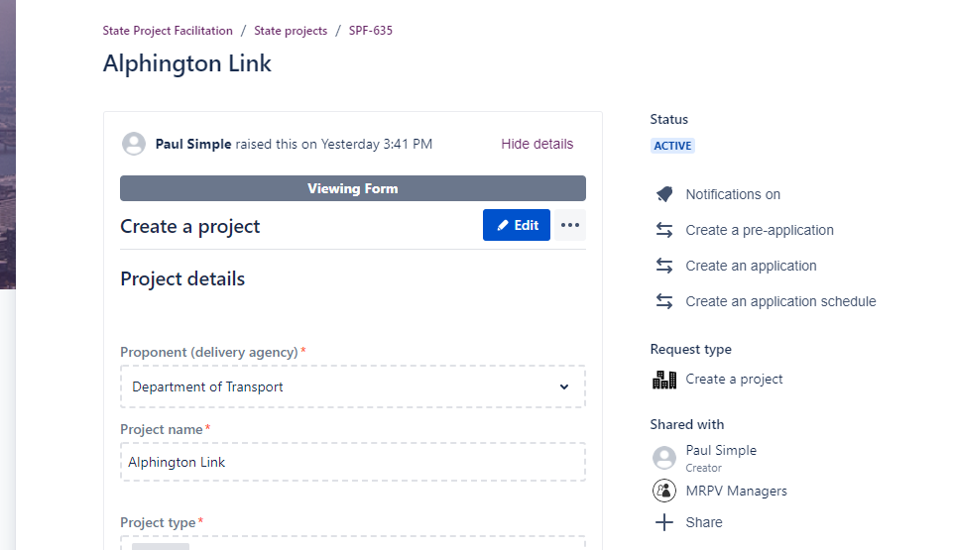
1
- You can choose to add a comment or just select ‘Create an application’. 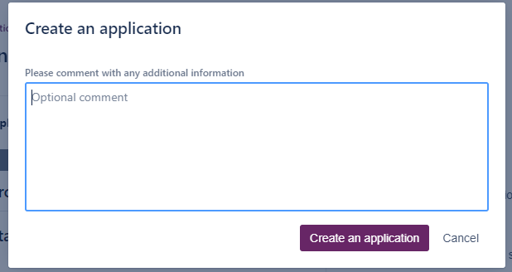
2
- The system will generate the application form, pre-populating it with project information. During this time, the status of the project will appear as ‘CREATING AN APPLICATION’.
- After 10 to 20 seconds, refresh (F5) the browser tab to see that the status has updated to Active. 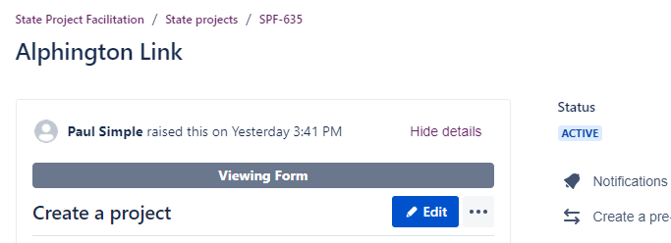
4
- Scroll to and expand the Issue Links listing and select the SPF number for the application that has been created. This will open the application in a new screen. 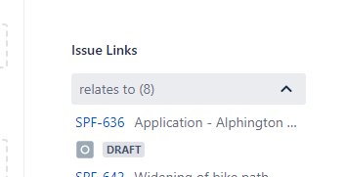
5
- Follow steps 19 to 28 of this section to edit the details in the form and to submit to the SPF team when complete.

Create and lodge and application form from the home screen
An application can be created from the SPF portal’s home screen. The user will need to know the SPF project number to include it in the application form. Hint: Navigate to the requests menu to identify projects shared with you by selecting ‘All requests’.
- From the home screen, select Lodge an application.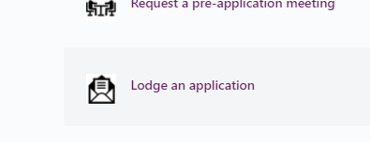
7
- An application name can be entered to identify the application. If no name is entered, on initial save, the application name will default as a combination of the application type, project name and proponent.
- If a pre-application meeting request was lodged via the portal, select ‘Yes’ and enter the relevant SPF number of the pre-application meeting request.
  - Where ‘No’ is selected, you will need to enter the project’s SPF number instead.
  - Entering the SPF number with either of these options will create a link to the pre-application meeting request and/or project, therefore not requiring the completion of project details again. 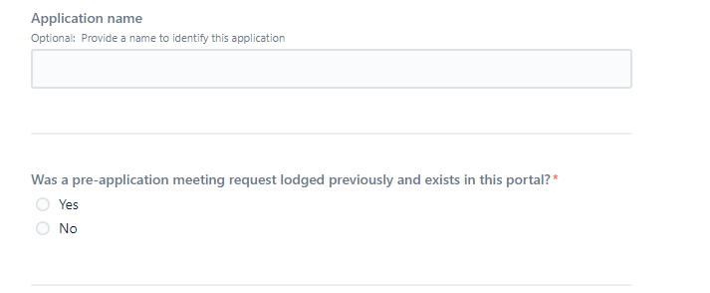
8
9
- You can choose to use the site details from the linked pre-application or project by selecting ‘Yes’, otherwise “No’ can be selected and the site names that are relevant to the application can be entered. Where ‘Yes’ is selected, the site names and planning scheme details from the project or pre-application record will be pulled through to their respective fields once it has been saved.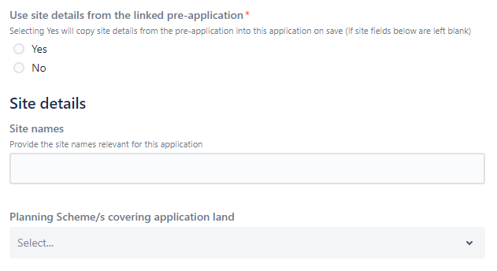
10
- At the Application details section, select the relevant legislation. If, Planning & Environment Act is selected, the relevant control will also need to be selected. Fields in the form will vary depending on the selection made throughout the form. Where a control is entered as VPP, then clause should be selected as well.
- Continue completing the form ensuring that all mandatory fields that are marked with a red asterix are completed. 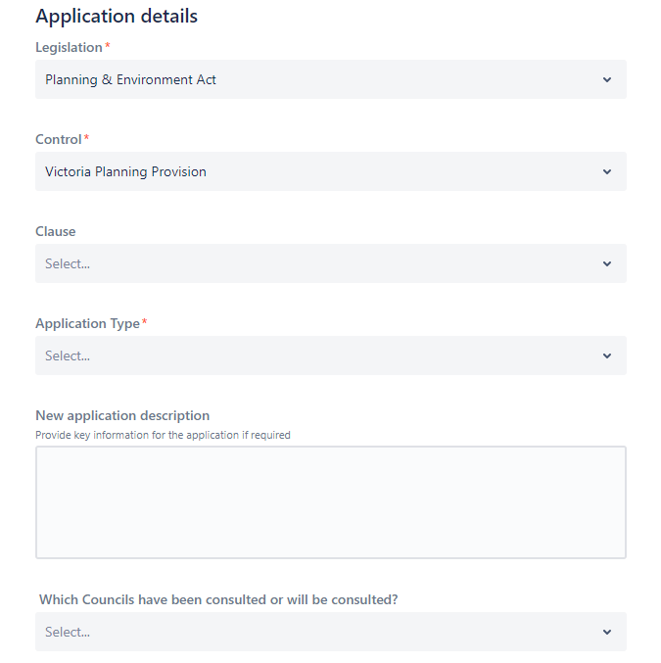
11
12
- You can choose to quickly upload attachments by scrolling to the top of the form and using the ‘Drop and Drag’ functionality to upload attachments to the form. Files can also be uploaded at a later stage.
- Use the attachment checklist (located at the top of the form) as a guide to ensure all required documentation is provided to the department at the time of lodgement. This will reduce delays during the assessment process and the likelihood of the application being returned to you for additional information.
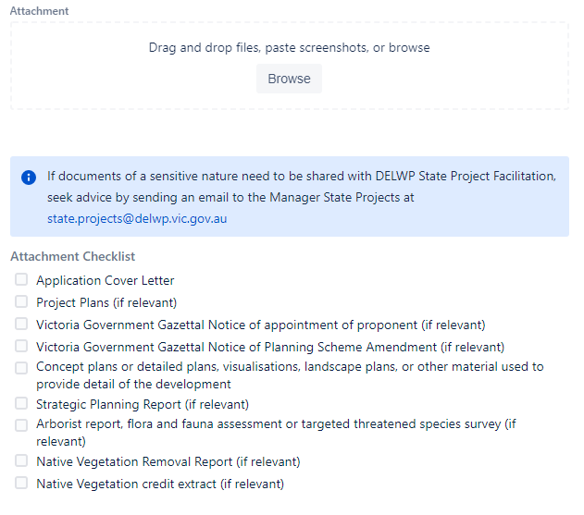
14
13
- Once all mandatory fields have been completed, the form can be saved and returned to at a later stage to edit as required prior to submitting to the department. To save, scroll to the end of the form and select SEND. Note that the application request will not have yet been submitted to the department.
15
- Once saved, the application request form will show on screen with the status of DRAFT. The application is not yet lodged with the department.
- Attachments that had been uploaded at the time the application was created will appear to the right under ‘Attachments’.
- Selecting the ellipses will show further functionality to generate a PDF of the application.
- Selecting Edit will open the request form to enable update to fields. 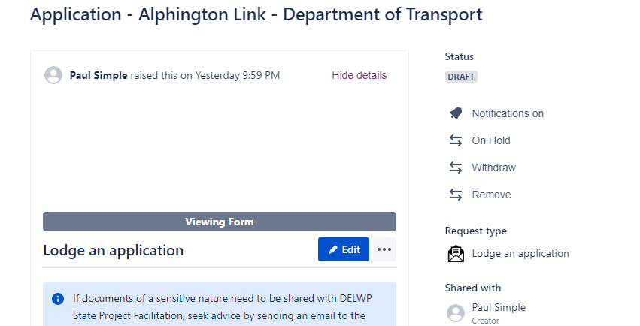
16
18
19
- The linked project and pre-application meeting request will appear in the Issue Links listing.
- If the application is no longer needed or was done in error and is not being submitted, it can be removed by selecting Remove.
- If editing the application request, make any changes as needed and when complete and if ready to submit, select Save and submit (or Submit if no changes made). 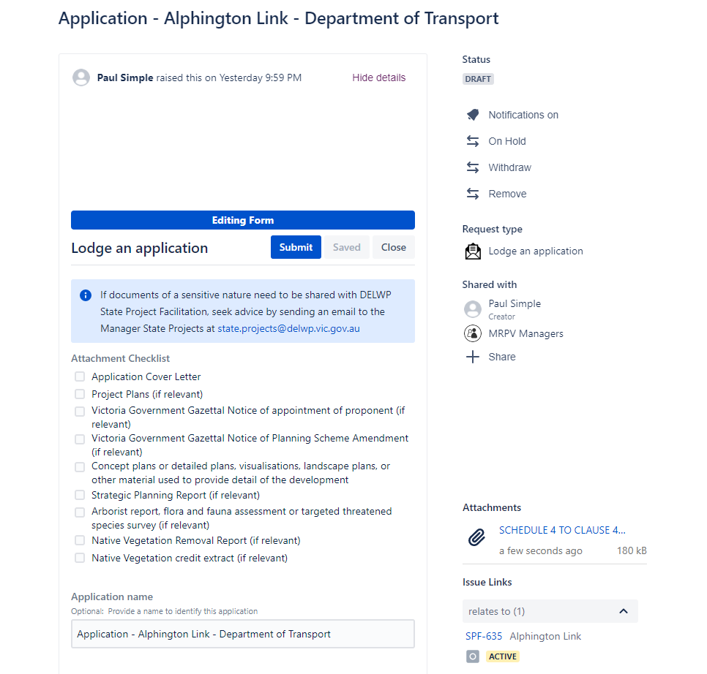
21
20
22
- Select Submit to confirm that the application request is complete and ready to submit to the department.
Note that no further changes can be made to the application request, unless it is unlocked by an authorised department user. Comments and files however can be uploaded if needed. 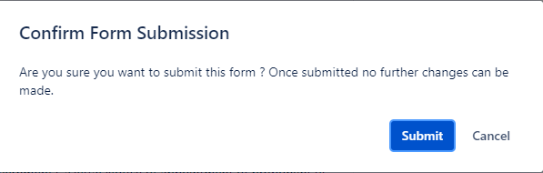
23
- Once submitted to the department, the status will update to RECEIVED (you may need to refresh (F5) the browser).
- It is also at this stage where the application can be placed On Hold or Withdrawn.
- The application request will also show the managers group that it has been shared with. It can be shared with additional registered users by selecting + Share. Important: Share with your managers group in order for Managers to see it in their request listing. 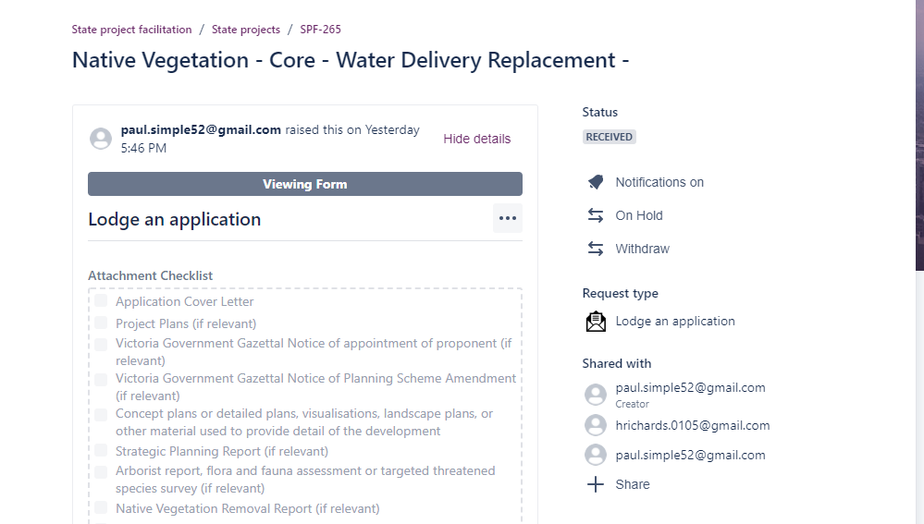
26
25
24
- Even after the form is submitted to the department, you can add comments if needed by scrolling to the Activity section of the form and selecting ‘Add a comment’.
27
- Once submitted, the creator of the form will receive an automated email confirming receipt.

Amend a previously approved application
Where an application has already been approved and a change to the application is required, there is a requirement to create and submit a request to amend the approved application via the SPF Portal.
If the approved application was lodged and managed via the SPF portal, the user will need to know the specific request number (i.e. SPF-###) that the approved application was lodged under.
By entering the SPF number of the approved application, the details of the project and approved application will automatically be linked to the amend approved application request.
If the approved application was lodged pre portal, there is an option to reference the previous application however a project will still need to exist in the portal in order to generate the request to amend the previously approved application.
- From the home screen of the SPF portal, select Amend a previously approved application.
1
- Files supporting the request can be uploaded by dragging and dropping the files in the Attachment section (or browse your device). Note once the form is saved, files can only be uploaded via the comments section of the form as well.
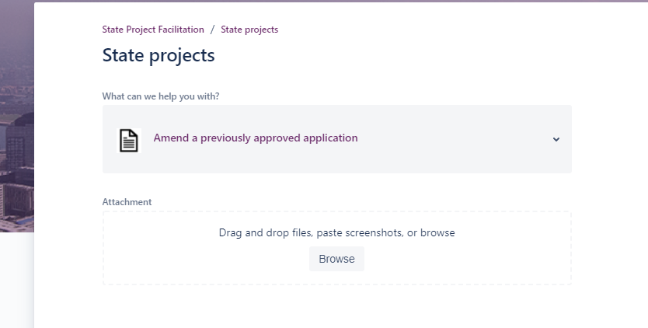
2
- Optionally, you can add in a name into the application. If left blank, the field will auto populate with ‘Application’ if linked to an existing application or will default to “app type” + “project name” + “proponent” if not linked to an application in the portal. The application name can also be edited at a later time before submitting the form to the department.
- If the application that is being amended was lodged and managed via the SPF portal, select Yes and enter the relevant SPF request number. Once saved, the linked application that is being amended will appear under the Issue Links section of the form.
- The SPF number for the approved application can be found via the Requests listing and changing the filter to show ‘Closed’ requests. (see section of this guide ‘Navigating the system…’ - step 6)
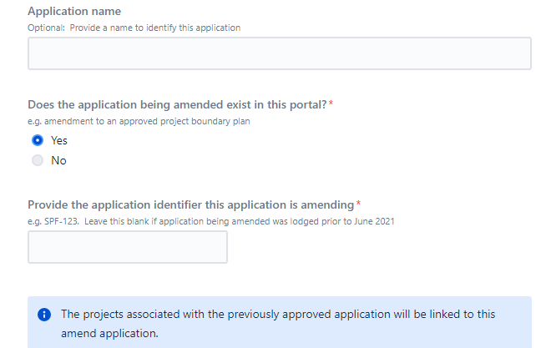
.
4
3
- Where the approved application was not lodged via the portal, a project will need to be created in the system and the SPF number from the project entered into the ‘Project details’ field. (see the ‘Create a project’ section if needed)
- Site names and planning scheme details can be added when they are not being copied from then the project. If they are being copied from the project, these details can be edited prior to submitting the form to the department.
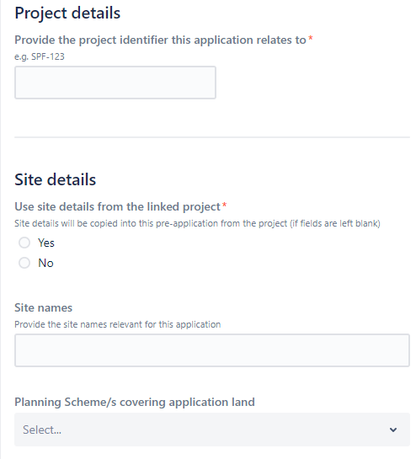
6
7
- Complete the application details section ensuring all required fields marked with a red asterix (*) are completed.
- Navigate to the end of the form, read through the privacy statement and select Send to save a draft.
Note: This will not submit the request to the department. 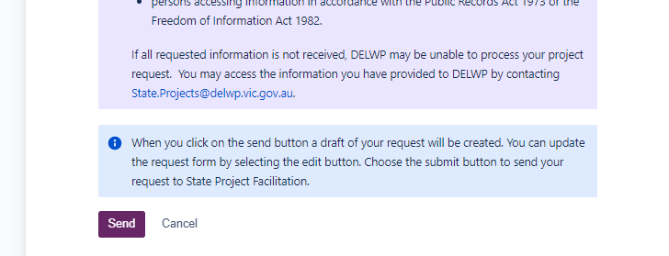
9
- After 10 to 15 seconds, refresh the web page (F5).
- The status of the application will be DRAFT.
- The request can be removed if no longer required. This will update the status to CLOSED.
- The request can be shared with other registered users of the SPF portal. It is important to share with the managers group at this stage if not already shared.
- Select the ellipses (‘…’) to download a PDF copy of the request.
- The linked previously approved application will be listed under Issue Links.
- Select Edit to open the form and to update fields. 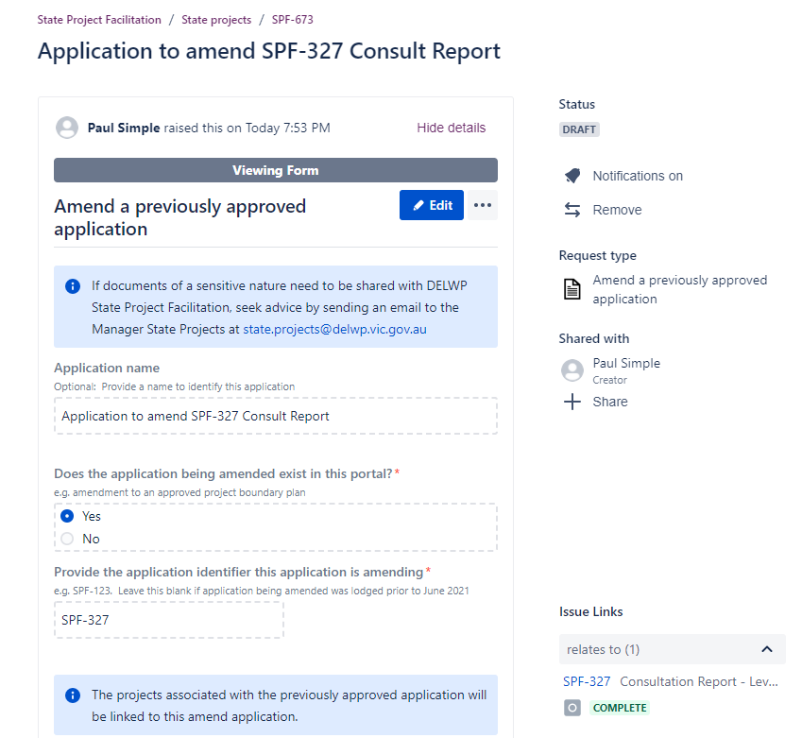
12
16
13
11
15
14
- Update details of the form as needed and when complete, select Save & Submit (or Save if not ready to submit, or Submit if no changes made). Note that no further change can be done to the form once submitted to the department. 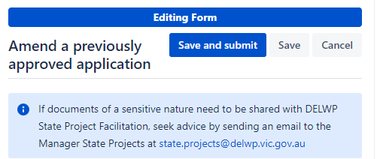
17
- Select Submit to confirm that the form is to be lodged with the department. 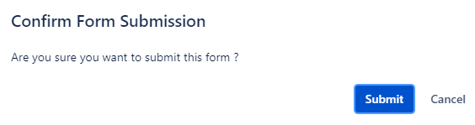
18
- Refresh the web page (F5).
- The request to amend an approved application will be submitted to the department, will be locked and the status will update to ‘RECEIVED’. The creator of the form should receive an email to confirm.
- From this point in time, you can choose to place the application to amend On Hold or Withdraw it.
- Selecting Update application will allow you to change the application name, reporter, RAG status, RAG comment, forecast date of approval, legislation and application type fields. Note: The concierge team of State Project will receive an email if the RAG status or RAG comment is updated.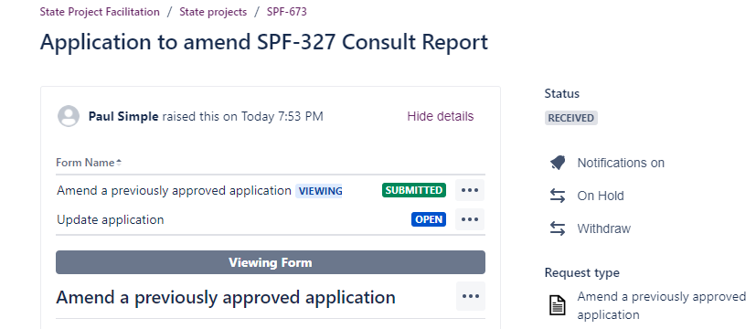
21
20
22

- Additional documents or comments can be uploaded in the Activity section of the form where selecting Add a comment will provide additional functionality to add comments and attachments. See the section ‘Upload files after application has been saved’ if needed.
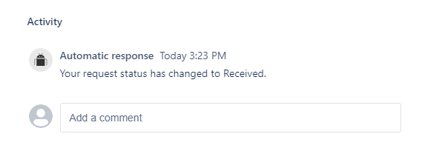
23

Upload files after application has been saved
When first creating an application from the home screen, any files can be simply added to the request via ‘drag and drop’ functionality. However, once the request has been saved, the only way to upload additional documents is via the Activity>Comments section when in an application request. The following guides the user on how to upload files after the request has been saved.
- Whilst in an application or other request type, navigate to the end of the request and in the Activity section click in the field to ‘Add a comment’.
1
- Once the field is selected, additional functions will be visible. Select the image icon (Files & Images).
- Navigate to the location of the files and upload as needed. Multiple files can be uploaded at the same time.
- Select Save to close the comments field where the uploaded file(s) should now be seen. 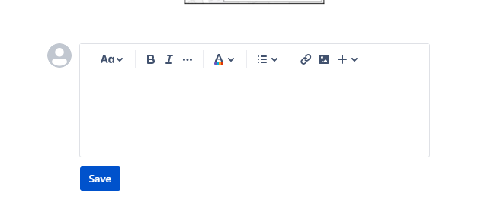
2
4
- Refresh (F5) the web page to see that the uploaded files are listed under the Attachments section located at the right of the form. 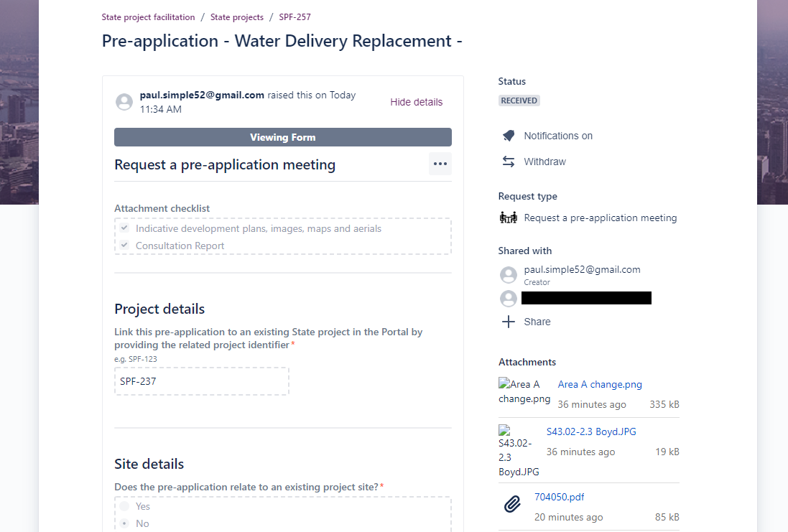
5

Share projects or applications with other registered users
When requests such as a project or application are shared with another registered user of the portal, they will be able to easily access the applications (or projects) from their ‘Requests’ dashboard. Sharing applications or other records from the portal is an efficient way to enable collaboration on the requests prior to them being lodged to the department. Sharing can occur at any stage/status.
Things to note:
- Can only share with registered users of the system
- Requests including Project records, applications and pre-applications, may need to be shared with a managers group in order for the management group of the proponent to see them in their requests listing.
It’s important to note that if a project has already been shared with a managers group, by default, any linked application will be shared with the group.
- With any request type open, select +Share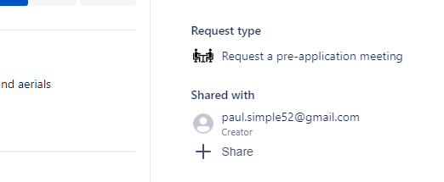
1
- Enter the email address or managers group and select Add.
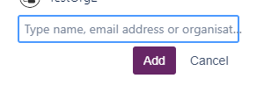
2
- The system will send an email to the recipient advising that the application has been shared with them.

Respond to a request for further information
When the assigned planner from the SPF team requires additional information for an application, they will use the system to request the required information by adding a comment to the request which will in turn send an email to the contact (Creator). The comments in the application will also show the request for further information that is being made and will include a due date that a response is required, if you do not want to impact approval timeframes. The status of the application will be changed to ‘Request for Further Information’. Responding to a request for further information must completed via the portal.
Sample of email received from State Project Facilitation with reference to the SPF application number: 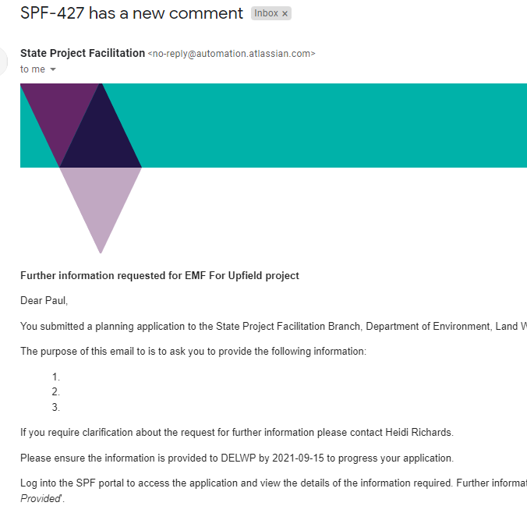

- With the application open, scroll to the end of the form where ‘Add a comment’ is located.
- Click in the ‘Add a comment’ field and enter the relevant information. 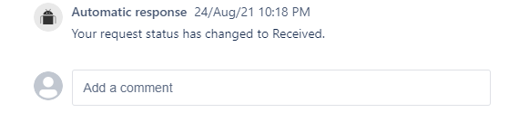
2
- Select the Files & images icon to upload supporting files. Multiple files can be uploaded.
- Select Save when complete.
3
4
- Scroll to the top of the application and select Information provided.
Important: It is important that ‘Information provided’ is selected after the comments section has been saved. This step will ensure the planner is aware the RFI has been supplied back to the department 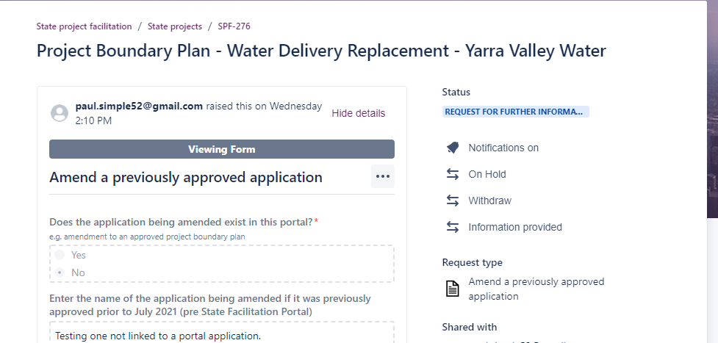
5
- Add any additional comments if needed (optional) and select Information provided. 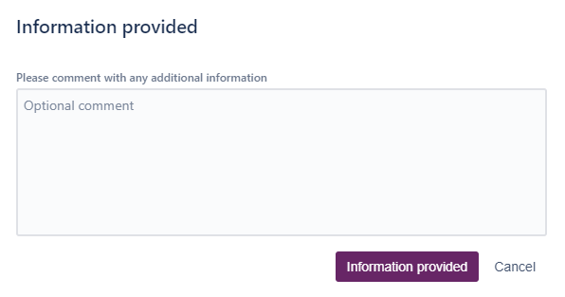
6
- The assigned department planner will receive an email notifying them of the response and the status will automatically update to UNDER REVIEW. 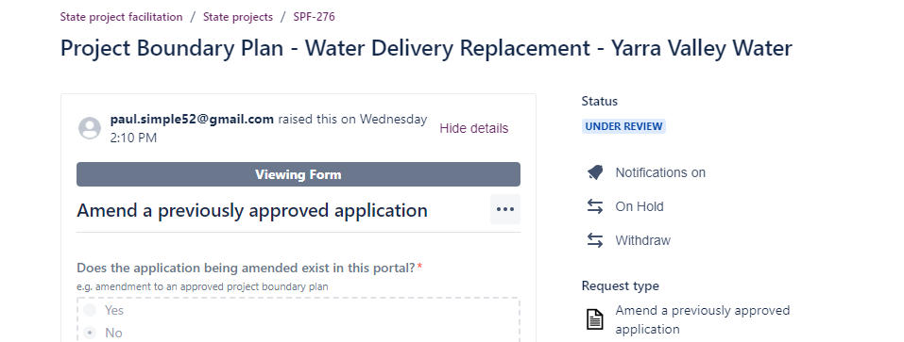
7

Withdraw an application or pre-application request
An application or request for a pre-application meeting with a status of RECEIVED can be withdrawn where the request is no longer required. Once withdrawn, the application will be closed.
- From the application record screen, select Withdraw. 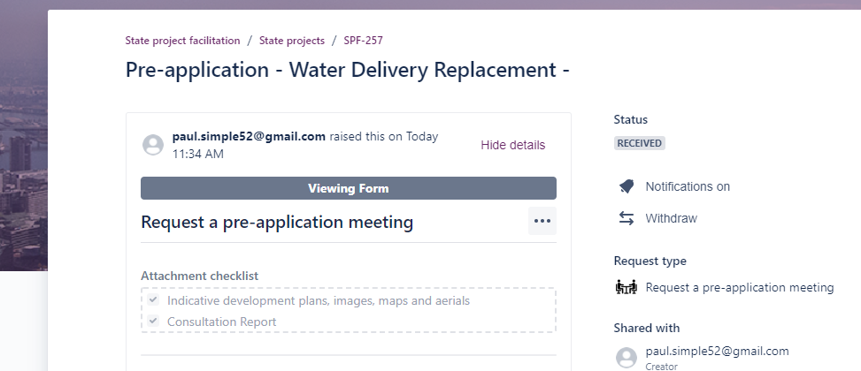
1
- Enter comments and select Withdraw. 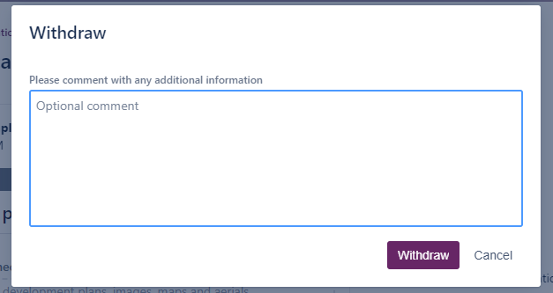
2
- The application status will be updated to COMPLETE and the form will not be able to be edited but can still be downloaded if needed.

Place application on hold / Request to take off hold
Applications that have been submitted to the department can be placed on hold. A comment must include the date the application is to be placed on hold until and the reason for request.
- With an application open, select On Hold. 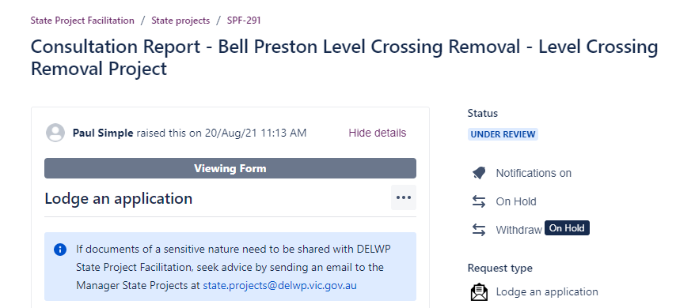
1
- Enter details regarding the on hold request and select On Hold. This will email the planner of the request, add the comment in the Activity section of the form and also place the application on hold. 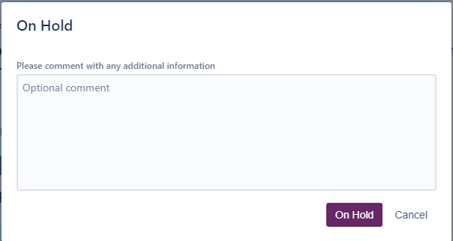
2
- Scroll to the Activity section of the form where you will see the date the application was requested to be placed on hold.
- Any further comments can be added if needed. 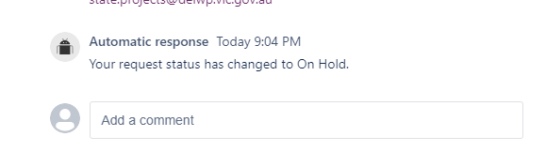
4
3
- You will need to contact the assigned planner to take the application off hold. The comments section of the form may be used for such a request.

Notify the State Project Concierge team of change in application’s progress status (nominated projects only)
The State Project Concierge service seeks to reduce approval barriers and delays on major projects. For nominated (agreed) projects, the Concierge will be the single point of contact for proponents to coordinate internal and external stakeholders to overcome barriers to progress.
Where a nominated project requires Concierge assistance, the SPF Jira Portal can be used to notify the Concierge of an update in the application’s RAG status and the team will receive an email. All applications, including applications to amend a previously approved application that have been submitted to the department for assessment will have an ‘Update application’ form. Using this form, the RAG status and a RAG comment can be updated.

- With the selected application open, select the Update application form (location in Form Name section). 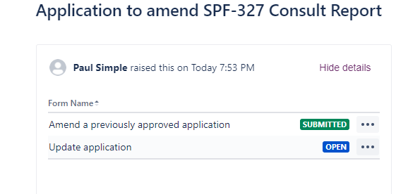
2
1
- With the Update application form in view, select Edit. 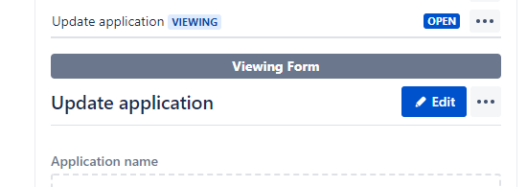
- Update the RAG status and RAG comment.
- Select Save and submit. This will send an email to the Concierge team with the updated details. 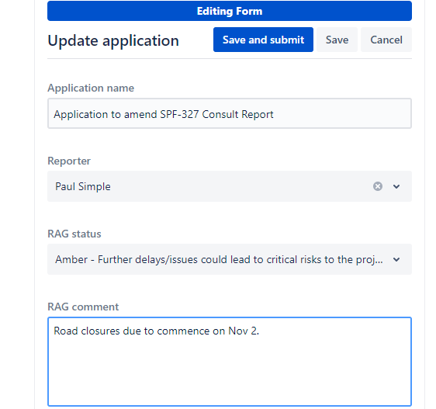
3
4

Update the reporter/contact on an application
The reporter (contact) of an application will receive emails throughout the various stages of the application assessment process such as when an application is first assigned to a planner in the department, when there is a request for further information and where an application has been determined. There may be a need to have the reporter updated to be another registered user of the system. For example when a staff member leaves the organisation.
2
- With the selected application open, select the Update application form (location in Form Name section).
1
- With the Update application form in view, select Edit.
- Select the Reporter field and enter the email address for the new contact.
- Select Save to save the changes.
3
4

Generate a report using Advance Requests report
A listing of requests in progress can be obtained from the SPF Portal via the Advance requests report tool. A report can be downloaded as an Excel or CSV file.

- Select the profile icon and Advance requests report.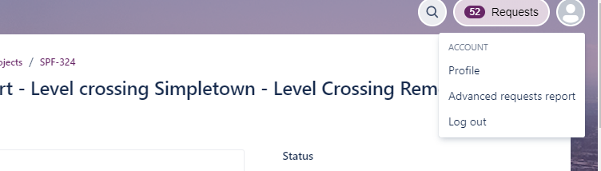
1
- Once the reporting tool has loaded, you can choose to filter the report to see particular request types or search for any request.
- The report can also be downloaded as an Excel or CSV file.
- To close the reporting tool, select the X located top right of screen. 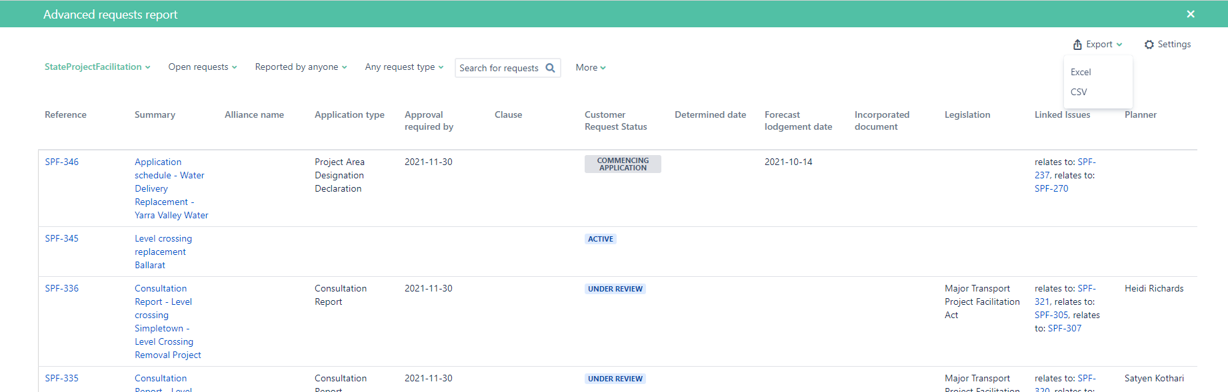
2
3
4
- Additional columns seen in the report can be managed by selecting Settings then click on any of the columns to switch on/off and selecting Save. The selection made will remain for when the reporting tool is accessed.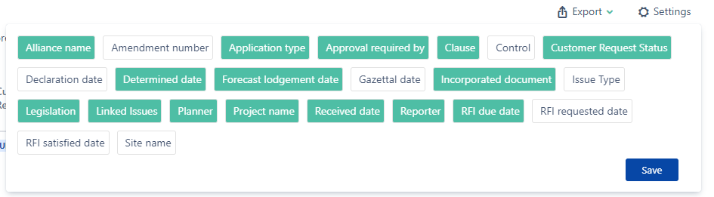
5

Which Planner is assigned to my application?
Users of the system can open up any application and see which Planner from the department is currently assigned to manage the application. An application that has been assigned will have a status of Under Review, Under Consideration or Determined for applications or Under Assessment if its related to a pre-application request. Also when an application is first assigned, the creator/contact for the application will be notified by email. Applications with a status of RECEIVED have not as yet been allocated to a planner.
- With an application open, scroll to the ‘Fields’ section, just above Attachments and Issue Links and it is here where you will find which Planner has been allocated the application. 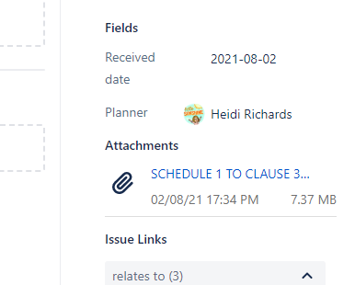
1

Understanding the status of an application
As an application moves through the various stages of the drafting, assessment and approval process, the status of the application will be updated. The table below may be helpful in understanding where an application is at through the assessment and approval stage.
Status | Meaning
Draft | The application has been created but is not yet submitted with the department for assessment and approval.
Received | The application has been submitted but not as yet assigned to a planner for assessment.
Under Review | The application has been assigned and is being assessed.
Under Consideration | The application is at the approval stage.
Complete | The application has been determined or withdrawn.
Request for Further Information | The assigned planner requires additional information in order to assess the application. See Respond to a request for further information for further details.
On Hold | A request to place the application on hold has been made.

Need further help or have feedback?
If you require further assistance with your request, contact the State Project Facilitation team via email at state.projects@delwp.vic.gov.au

If you have feedback on the system, visit the SPF Yammer Community where you can also stay up to date with the conversation whilst sharing feedback.

