Warracknabeal Energy Park Environment Effects Statement (EES)

Scoping Requirements FAQs December 2024



1. What is the Warracknabeal Energy Park project?

The Warracknabeal Energy Park project is a proposed wind farm located in the Yarriambiack Shire local government area of north-west Victoria. The project area is approximately 5 kilometres (km) away from the township of Warracknabeal, and approximately 40km north of Horsham (Figure 1).

The project consists of the following proposed components and activities:

* Up to 230 wind turbines with a maximum blade tip height of up to 280 m
* Approximately 282 km of underground cabling and 21km of overhead powerlines
* Two battery storage facilities
* Approximately 13 km of overhead transmission lines to connect the project to the Murra Warra terminal station.
* Approximately 223 km of new access tracks.

The project proposes a total capacity of approximately 1,650 MW and annual production of approximately 5,200 GWh of electricity per annum. The operational life of the project is anticipated to be 25 years.

1. What is the purpose of the EES scoping requirements?

Warracknabeal Energy Park Pty Ltd (the proponent) is preparing an environment effects statement (EES) for the Warracknabeal Energy Park project.

The scoping requirements set out the matters to be investigated and documented within the EES. The EES will include a description of the proposed project, rigorous assessment of its potential effects on the environment and approaches to manage those effects.

The EES scoping requirements have been issued by the Minister for Planning and are available on the Planning website:

<https://www.planning.vic.gov.au/environment-assessment/browse-projects/projects/warracknabeal-energy-park>

1. Did the public have an opportunity to comment on the scoping requirements?

Yes. Draft scoping requirements for the EES were exhibited on the Engage Victoria website from 23 August to 16 September 2024. Notice of the draft scoping requirements’ exhibition was advertised in metropolitan and local newspapers.

85 submissions were received during the public exhibition period, including from individuals and other stakeholders.

Submissions received have been provided to Warracknabeal Energy Park Pty Ltd to inform the ongoing development of the EES.

1. What issues were raised in public submissions on the draft scoping requirements?

Issues raised by submitters included concerns about:

* social and community values, including health impacts from noise, traffic generated during construction and the availability of accommodation for the workforce;
* biodiversity values, including potential impacts to birds of prey and removal of native vegetation;
* agricultural values from the use of farming land and biosecurity risks;
* impacts to landscape and visual amenity; and
* mining interests in the project land.

1. What revisions have been made to the draft scoping requirements in response to public submissions?

One amendment has been made to the scoping requirements to clarify that biosecurity issues are to be considered in the EES.

Most of the other relevant concerns raised in the submissions were considered to be adequately covered by existing requirements. For example, concerns regarding impacts to social, community and public health impacts are covered by the requirements of sections 4.4, 4.5 and 4.6, which require the proponent to consider the potential for the project to result in impacts to the community through aspects such as shadow flicker, visual amenity, noise and vibration, and the social fabric of the community (with regard to wellbeing and community cohesion).

Further, concerns relating to the traffic volumes and impacts to road surfaces are covered by the requirements set out in section 4.7, which require the proponent to assess the potential effects of construction activities on existing traffic, preferred traffic routes and road conditions, including physical impacts to the road infrastructure; and concerns regarding impacts to biodiversity values and raptors are covered by the requirements in section 4.1, which require the proponent to assess the direct and indirect effects of the project on native vegetation, listed ecological communities, and listed threatened, migratory and other protected flora and fauna species (including raptors).

Additionally, some minor amendments were made to the scoping requirements after discussion with the proponent, notably the removal of the reference to of an on-site quarry as this is not proposed as part of the project.

1. What happens now the Minister has issued the final scoping requirements?

Warracknabeal Energy Park Pty Ltd will address the matters set out in the scoping requirements through investigating environmental impacts, gathering information and preparing EES documents, in consultation with the Department of Transport and Planning and a technical reference group. The technical reference group is comprised of representatives from government agencies, regional authorities, municipal councils and registered Aboriginal parties (RAPs) with a statutory or policy interest in the project and its effects.

Warracknabeal Energy Park Pty Ltd will also engage the public and stakeholders about the environmental effects of the project and its investigations and provide opportunities for input and feedback to inform the EES. Warracknabeal Energy Park Pty Ltd’s EES consultation plan can be viewed at: <https://www.planning.vic.gov.au/environmental-assessments/browse-projects/referrals/warracknabeal-energy-park>.

When the EES has been completed in accordance with the scoping requirements, the Minister for Planning will authorise the EES for exhibition and public comment, typically for a period of 30 business days.

The Minister will appoint an inquiry under the *Environment Effects Act 1978* to consider the EES and submissions received. The inquiry may hold a formal hearing where the proponent and submitters can speak and present expert witnesses to inform a report to the Minister. The Minister will then make an assessment of the project’s environmental effects.

After the Minister has made an assessment, the inquiry report and the Minister’s assessment will be published on the Planning website.

The Minister’s assessment will be considered by statutory decision-makers responsible for the project’s approvals.

1. What about the Commonwealth Environment Protection and Biodiversity Conservation Act?

The project was also referred to the Australian Government under the Commonwealth’s *Environment Protection and Biodiversity Conservation Act 1999* (EPBC Act). The delegate for the former Minister for the Environment determined in October 2023 that the project is a ‘controlled action’ requiring assessment and approval under the EPBC Act. The provisions for the Australian Government’s controlled action decision under the EPBC Act are:

* listed threatened species and communities (sections 18 & 18A); and
* listed migratory species (sections 20 & 20A).

The EES process is accredited to assess impacts on matters of national environmental significance under the EPBC Act through the Bilateral (Assessment) Agreement between the Commonwealth and the State of Victoria. The EES for the project will be undertaken in accordance with the bilateral agreement; there will be no separate assessment by the Commonwealth. The Victorian Minister’s assessment will be provided to the Commonwealth to inform their decision about the approval required for the project under the EPBC Act. The final EES scoping requirements identify matters relating to the EPBC controlled action decision, so that the EES can appropriately address these matters of national environmental significance that need to be assessed.

1. **When does Warracknabeal Energy Park Pty Ltd expect to publicly exhibit its EES?**

The EES is expected to be on public exhibition in 2025. During this period, the public can make submissions on the EES.

1. **Why is an EES required for the Warracknabeal Energy Park project?**

In September 2023, the Minister for Planning determined that an EES is required for the Warracknabeal Energy Park project. This was because the project has the potential for a range of significant effects relating to:

* significant biodiversity values, including threatened species and communities listed under the *Flora and Fauna Guarantee Act 1988* and *Environment Protection and Biodiversity Conservation Act 1999*;
* native vegetation and ecology of the area’s terrestrial environments and freshwater environments, including wetlands and creeks;
* the Aboriginal cultural heritage; and
* landscape and visual amenity.

There is uncertainty about the extent and magnitude of potential effects related to historic heritage, traffic, shadow flicker, soils, surface water, electromagnetic interference, aviation, amenity and socioeconomic values that also require further assessment.

The project also has the potential for cumulative adverse effects on the above-mentioned values from the combination of proposed works, and other existing and publicly known proposed projects within the region.

An EES is the most comprehensive and robust assessment process available in Victoria. The EES will provide an integrated and transparent examination of the proposed project and its environmental effects.

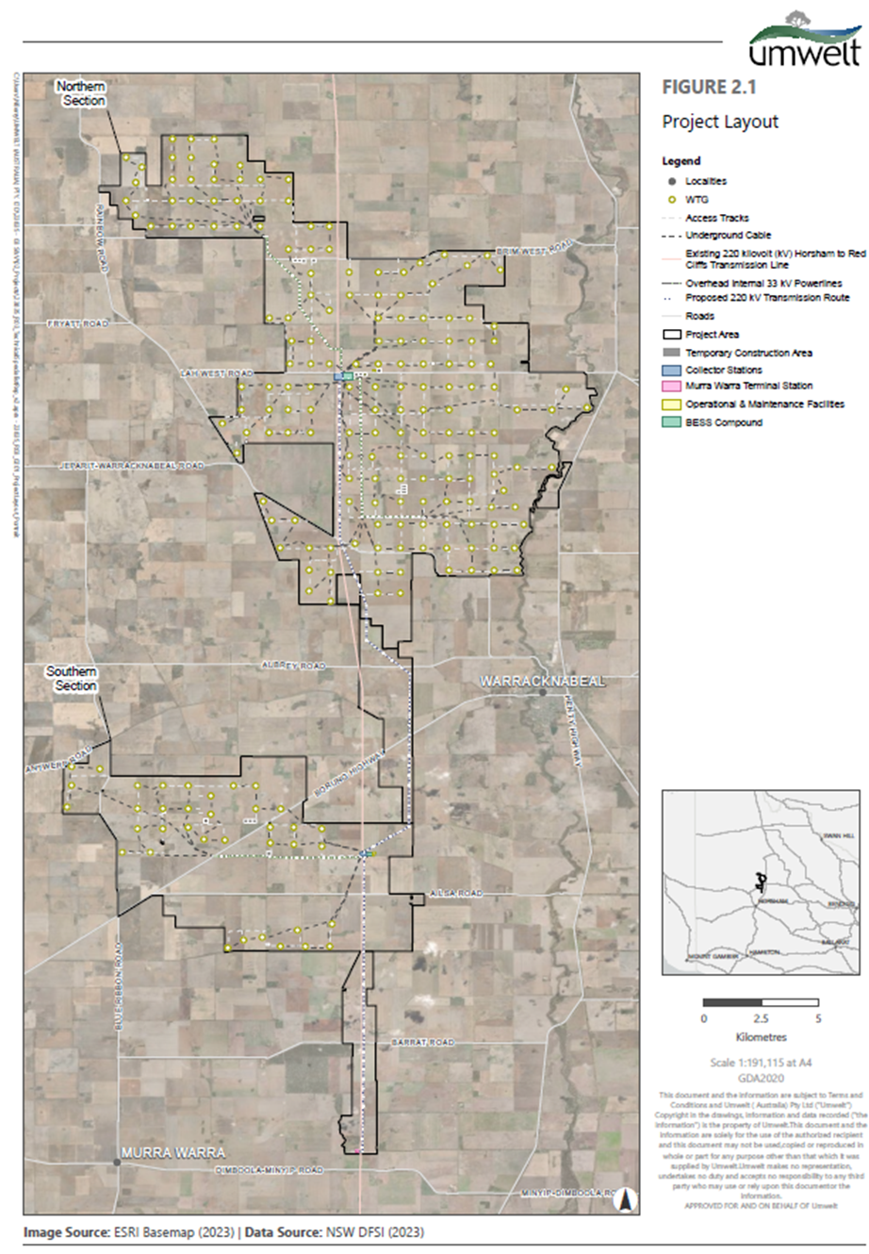  
Figure 1: Project location (Warracknabeal Energy Park project)